**SPRING**

ref:

[*https://codegym.cc/groups/posts/229-spring-for-lazy-people-foundation-basic-concepts-and-examples-with-code-part-1*](https://codegym.cc/groups/posts/229-spring-for-lazy-people-foundation-basic-concepts-and-examples-with-code-part-1)

The Spring, is one of the most popular framework to build a web app using Java. Spring is a framework, but it is not necessarily have to depend on classes or interfaces of the framework. Spring tries as much as possible to avoid such tight coupling. Spring uses *annotations* to achieve this.

* **Structure**

Spring is not just one particular framework, it is a common name used to refer to several small frameworks, with each of which does its own kind of work.

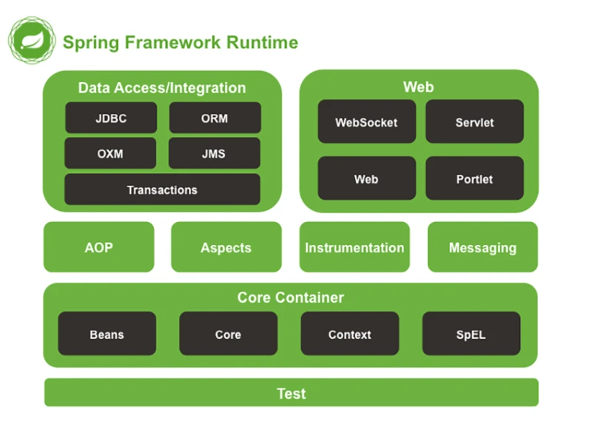

Spring only connect us with the modules we need for our app.

The image shows that spring consist of several modules, which is Data Access, Web, Core, etc.

The Data Access module contains tools for working with data (mainly databases), and

the Web module is for working on a network.

In addition, there is a comprehensive infrastructure that supports Spring: many other projects that are not officially included in the framework itself, but are seamlessly integrated into your Spring project (for example, Spring Security)

* **Why Java have Spring?**

Well, besides the fact that it is fashionable, slick, and fresh, I can say right now that as soon as you get even a small amount of skill using Spring, you will understand how there are all kinds of work that you no longer have to do, and how much work Spring takes upon itself. You can write a couple dozen lines of configuration settings and write a couple of classes, and you end up with a working project.

* **DI / IoC**

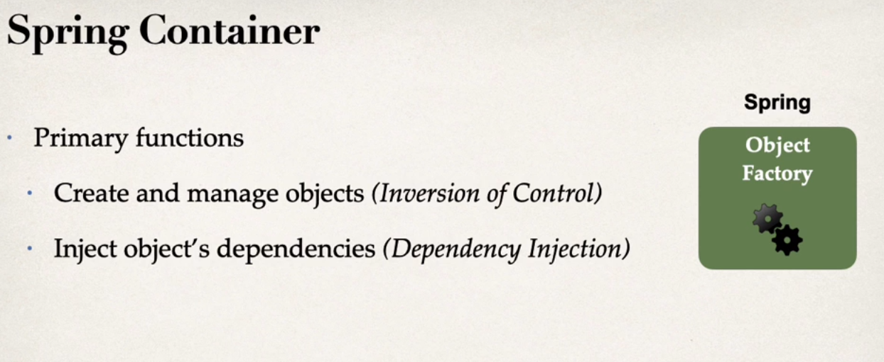

<https://dzone.com/articles/ioc-vs-di>

* **Inversion of Control**

*“ IoC is when you have someone else create objects for you”*

Instead of writing ***new myObjects*** in out code, the object is created by someone else, or normally referred to as an IoC container.

This simple explanation illustrates some very important ideas:

1. It is called IoC because control of the object is **inverted**. It is not the programmer who controls it, but someone else.

2. IoC is relative in the sense that it only applies to objects of the application. So there may be IoC for some objects, whereas others are under the direct control of the programmer.

Apart from Spring, there are other examples of IoC like **Java Servlets** and **Akka Actors**.

**Let’s delve into the details!**

IoC is much more than object creation: a Spring Context not only create objects, but manage their entire **lifecycle.** That includes creating objects, destroying them, and invoking certain methods of the object at different stages of its lifecycle. These methods are often called as **callbacks**.

Method invoked by the container are **callbacks**, as opposed to the **direct calls** that programmers make on their own code.

Another thing to consider is that, although programmers relinquish their control on the objects, **they still need to define the *templates*** used by the IoC container **to create the said objects**.

For instance, in Spring, classes are annotated with *@Component* or *@Service* (etc) to indicate that the Spring Container is to manage the instance of those classes (it is also possible to use XML configuration). **Spring-managed objects**, as you likely know, are called **Beans**.

Here is a quick summary of the ideas discussed so far:

1. IoC containers control and manage the lifecycle of some objects: creation, destruction, and callback invocations.
2. The programmer must identify the classes whose instances are to be managed by the IoC container. There are several ways to do this: with annotations, by extending some specific classes, using external configuration.
3. The programmer can influence, to some extent, the way the objects are managed by the IoC container. Normally, this is achieved by overriding the default behavior of the object callbacks.

* **Dependency Injection**

It has become one of the cornerstones of modern software engineering, as it is fundamental to allow proper testing.  To put it simply, having DI is the **opposite to having hardcoded dependencies**.

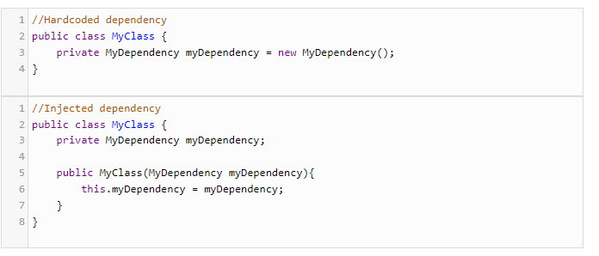

A dependency can be injected in several ways, like a parameter in the constructor or through a “set” method.

As important as DI is, there’s a downside to its use, namely: **management of dependencies is inconvenient**.

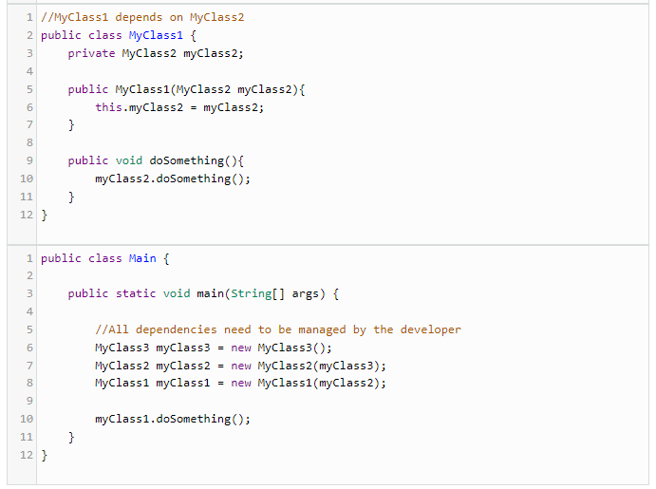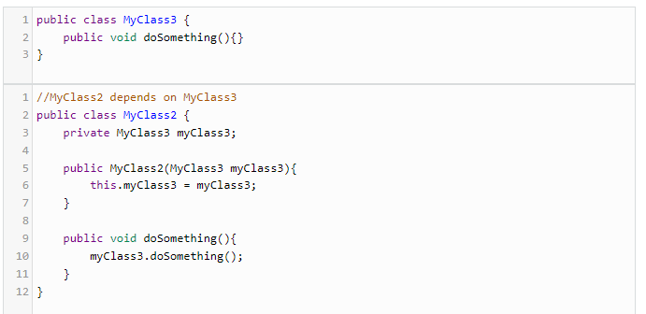Let’s take a look at an example: MyClass1 depends on MyClass2, that in turns depends upon MyClass3:

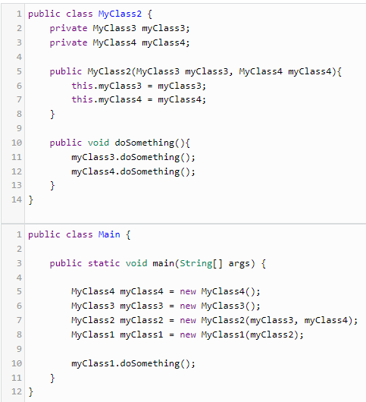Now, let’s assume that further down the line, MyClass2 needs a new dependency: MyClass4. We need to make changes to account for this new dependency:

Although the situation described in this example is not too bad, real-life applications can have hundreds of dependencies scattered all across the codebase whose creation and management would need to be centralized like in the above example.

* **Inversion of Control and Dependency Injection *Playing Together***

We just discussed the issue of managing hundreds of dependencies in a real-life application, possibly with very complicated dependency graphs.

So here is where IoC comes to the rescue!

With IoC, the dependencies are **managed by the container**, and the programmer is relieved of that burdern.

Using *annotations* like *@Autowired*, the container is asked to **inject a dependency where it is needed**, and the programmers do not need to create/manage those dependencies by themselves.

Back to codegym

**IoC is stands for Inversion of Control.**

I already mentioned this in passing when I wrote that using a library involves you indicating in your code which method to call on which object, but that using a framework generally means that the framework will call your code at the right time.

In other words, in this latter case, you are no longer managing the process of executing the code/program — the framework does this for you. You passed control to the framework (inversion of control).

**DI is stands for Dependency Injection.**

With dependency injection, you don't create cat objects in the main method and then pass them to your methods. Instead, the Spring Framework creates them for you. You simply say something like "I want to get a cat here" and the framework passes one to you in your method.

from Udemy

**Injection Types**

There are multiple types of injection with Spring. The recommended types are Constructor Injection and Setter Injection.

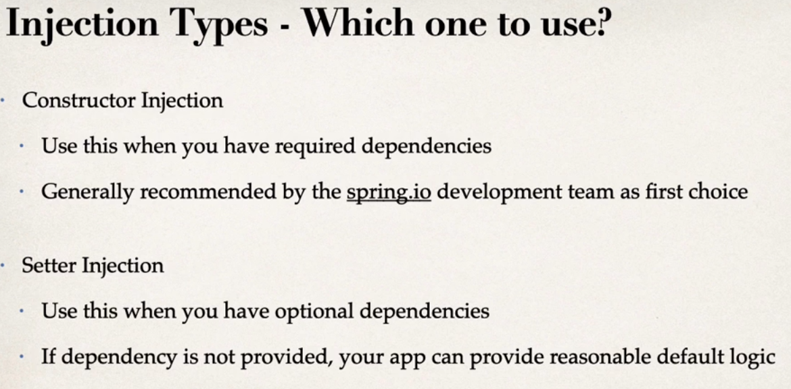

**Spring AutoWiring**

For dependency injection, Spring can use autowiring. Spring will look for a class that matches by the type (class or interface). Spring will inject it automatically, hence it is **autowired**.

For example, I have a Coach file. We can injecting a Coach implementation, Spring will scan for @Components and see if any one implements the Coach interface. If so, let’s inject them. For exp, we can inject *Cricket Coach* as a dependencies

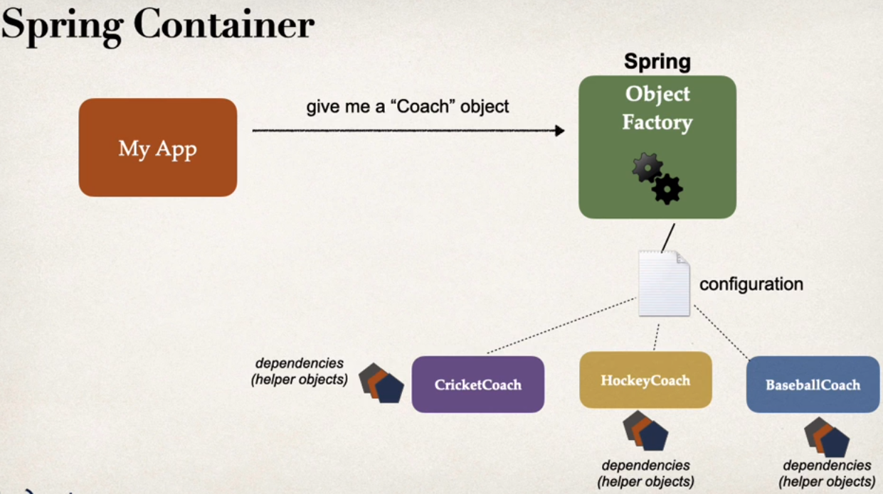

if you only have on constructor in a class, then @Autowired on constructor is optional!

Proj. Example

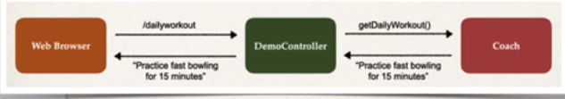

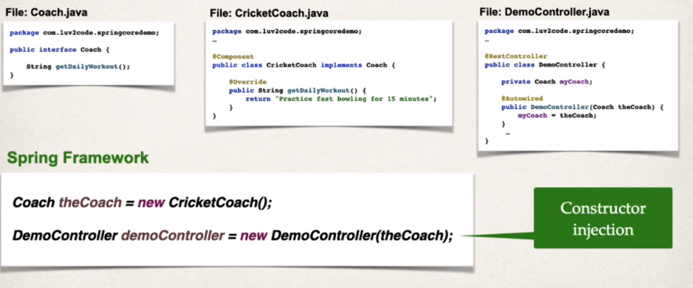**How Spring processes your application?**

Behind the scene, Spring Framework will create an new instance of your Coach, a new CiricketCoach. It’ll also perform a Constructor injection with our DemoController, It’ll actually inject the coach into the demo controller. The Coach is a dependency or a helper for the actual controller.

**from codegym**

* **Beans and context**

**Bean is just an object of some class.**

Suppose we have a program that requires 3 objects: a cat, a dog, and a parrot.

And we have a bunch of classes with a bunch of methods. Sometimes we need a cat for a method, sometimes we need a dog for a different method, and sometimes our methods need both a cat and a parrot (for example, the method for feeding the cat).

For still other methods, all three objects are needed. Yes, we could first create these three objects in the main method, and then pass them to our classes, and then within these classes pass them to the relevant methods, and so on throughout the entire program

But if we also suppose that we occasionally want to change the list of input parameters for our methods (for example, we decide to rewrite something or add new functionality),

example:

methodAnimals(Cat cats)

change the list of input parameters to : methodAnimals(Cat cats, Parrot bird)

,then we will have to make quite a few changes to the code. And now imagine that we have not 3, but 300 such objects.

One alternative would be **to gather up all our objects in one list (List<Object>), pass it to every method, and then get the necessary object while inside the methods**. But as the program runs, what if some object is added to this list, or worse, what if one is deleted? This has the potential to break every method where we use an index to get objects from the list.

To avoid this problem, we decide to store our objects not in a list, but in a map, where the key is the object's name and the value is the object itself.

This allows us to retrieve the objects we need simply by using their name, e.g. get("parrot"), and in response, we get the parrot object. Or the key could be the object's class, and the value could be the object itself.

In this case, rather than specifying the name of the object, but can just specify the class of the object we need. That's also convenient. Or we could even write some kind of wrapper for the map, where some methods get objects by their name, and other methods get objects by their class.

What we have arrived at here is called an **application context** in the Spring Framework.

**A context is a collection of beans (objects).** We access a context to get the bean (object) we need by its name, by its type, or by some other means.

Additionally, we can ask Spring itself to go look in its own context for the bean we need and pass it to our method.

For example, suppose we had a method like this:

**public** **void** doSomething(Cat cat) {

...

}

When Spring called this method, it took our cat object from its context and passed it to the method. But now we've decided that, in addition to a cat, our method also needs a parrot. With Spring, nothing could be easier! We simply write:

**public** **void** doSomething(Cat cat, Parrot parrot) {

...

}

Now when Spring calls our method, it understands the need to pass a cat and a parrot, so it goes to its context, gets these two objects, and passes them to our method.

*By transferring the reins of control to Spring, we also transfer responsibility for creating objects and passing them to our methods, which Spring will call.*

This begs the question: **how does Spring know which objects (beans) to create?**

**Ways to configure an application**

There are **three main ways to configure an application**, that is, ways to tell Spring exactly which objects we need:

1. XML configuration files
2. Java-based configuration
3. automatic configuration

**Spring's creators prioritize them in this order:**

* the method with the top priority, which should be preferred, is automatic configuration
* if automatic configuration can't be used to correctly configure all the possible beans, use Java-based configuration (which involves creating objects using Java code)
* and the lowest-priority method is the old-fashioned way — using XML config files.

Spring also lets us combine these methods.

For example, let Spring configure everything that can be configured automatically, use Java-based configuration wherever you need special parameters, and use XML for any legacy configurations. This all works out to be quite flexible. Still, if everything can be configured automatically, choose that option.

Automatic configuration is used when we need to work with objects of classes that we wrote.

If creating one of our objects requires some very specific logic, or if we are unable to make some class with the annotation necessary for automatic configuration, then we can use Java-based configuration to do what needs to be done.

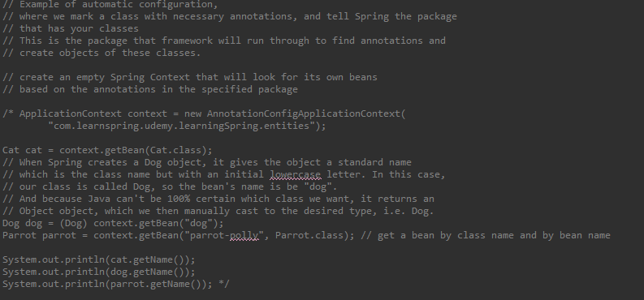

**Java-based Configuration**

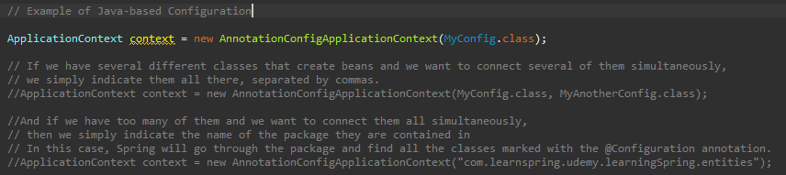

When creating a context, Spring will look for a class marked with the **@Configuration** annotation and will create its own object of that class. It attempts to call methods marked with **@Bean** annotation, which means that these methods return beans (objects) that Spring will add to the context.

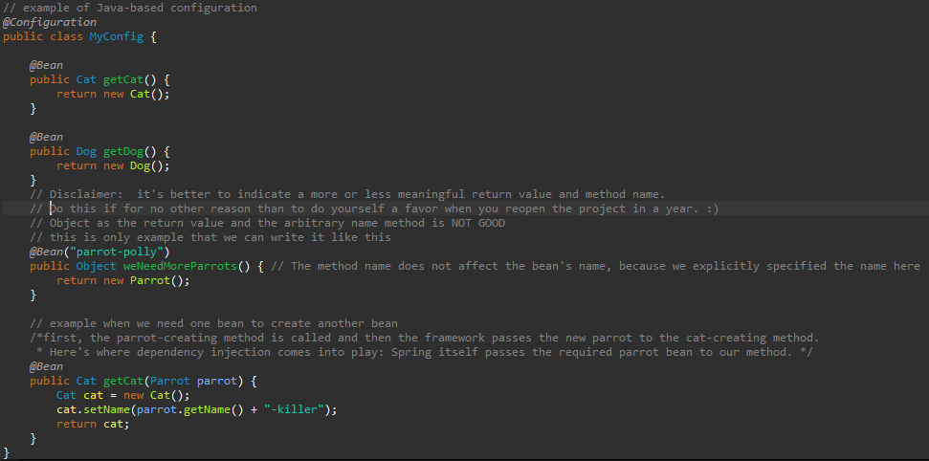

In addition, Java-based configuration lets you run **absolutely any Java code** in your bean-creating methods. You can really do anything: create other auxiliary objects, call any other methods, even those not marked with Spring annotations, create loops, Boolean conditions — whatever comes to mind!

**Udemy**

Create REST Controller

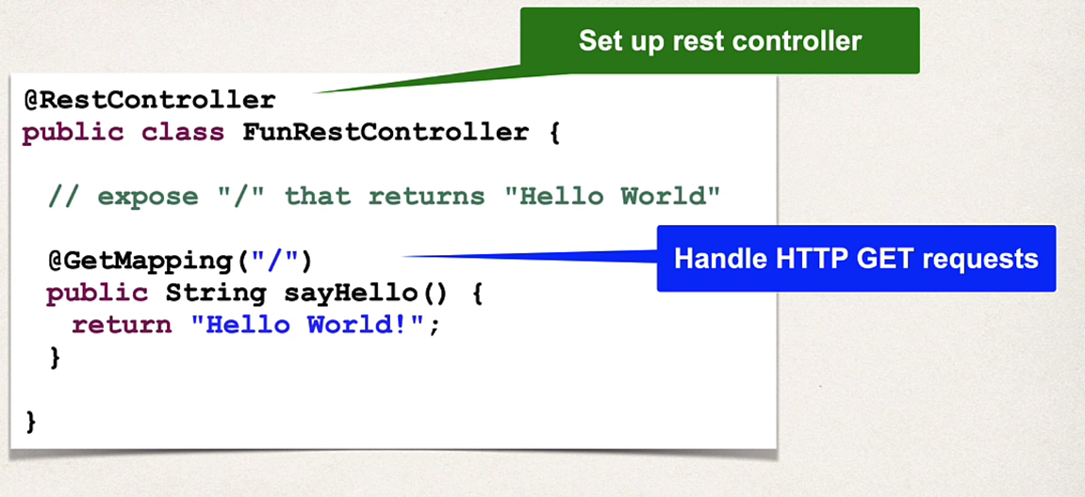

**Goals of Spring**

* Lightweight development with Java POJOs
* Dependency injection to promote loose coupling
* Minimize boilerplate Java code

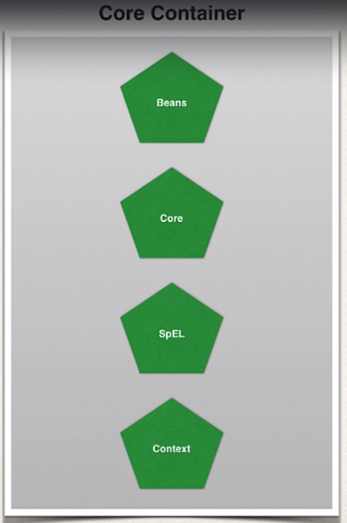**Big picture of Spring Framework**

it manages how beans are created. It has a bean factory for creating the beans. It basically can read config files for setting properties and dependencies. And also, the context here is really the Spring container that holds the beans in memory, and then as SpEL, that's for the Spring Expression Language. So, it's a little language we can use within the config files to refer to other beans.

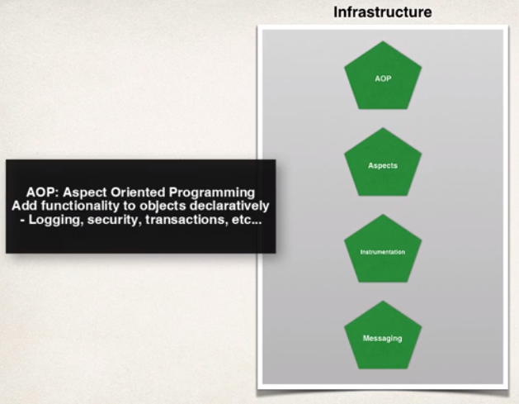

So, this is where you have support for Aspect Oriented Programming. So basically with AOP in a nutshell, it allows you to create these application wide services like logging, security, transactions, instrumentation, and then you can apply these services to your objects in a declarative fashion.

So, no need to modify your code to have support for this. You simply add a config in the config file or an annotation, and that service will be applied to your application.

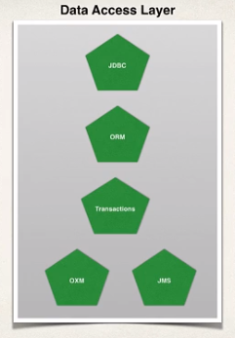So basically here, this is for like communicating with the database, either a relational database or a NoSQL database, and also making use of like a message queue. So in the top left, you have JDBC. Basically Spring provides some helper classes to make it much easier to access a database using JDBC. And by using these spring JDBC classes, you can actually reduce your source code by over 50%. So, a lot of good helper classes there. The next little bullet there is ORM, for Object to Relational Mapping. This is probably the most popular section of this module here. Basically, it allows you to hook into Hibernate or hook into JPA. So, a lot of support, and a lot of synergy between Spring and Hibernate.

MS or Java Message Service allows you to send messages to a message queue in an asynchronous fashion, that's a core part of Java EE. Here they basically provide helper classes to allow you to make use of the Java Message Service. And again, you can reduce your code by over 50% by making use of Spring's JMS integration. And then also Spring has support for a transaction manager or supporting transactions, and you can do this in a very lightweight fashion.

So you can make use of transactions on methods, on database calls, and pretty much anything you want, it's very flexible. And a lot of other projects in the world or on the web make use of the Spring transaction manager.

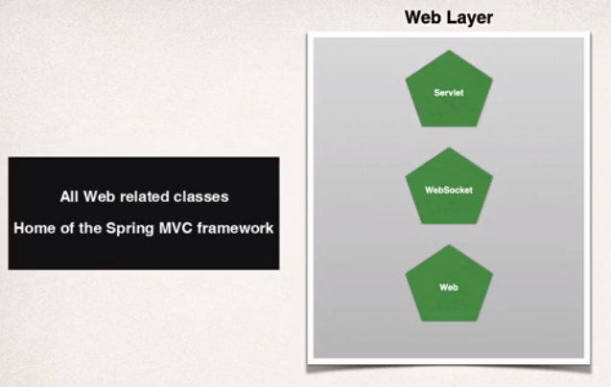

**MAVEN**

is a project management tool, to build management and dependencies tools

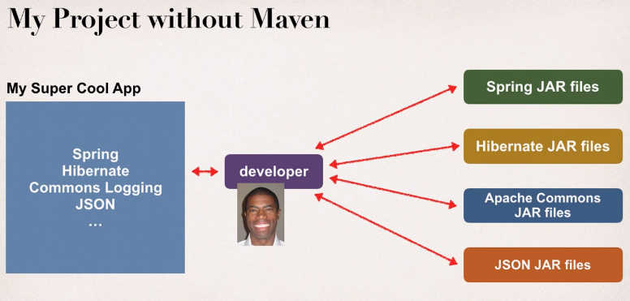

Maven will go out and download the JAR files for those projects for you!

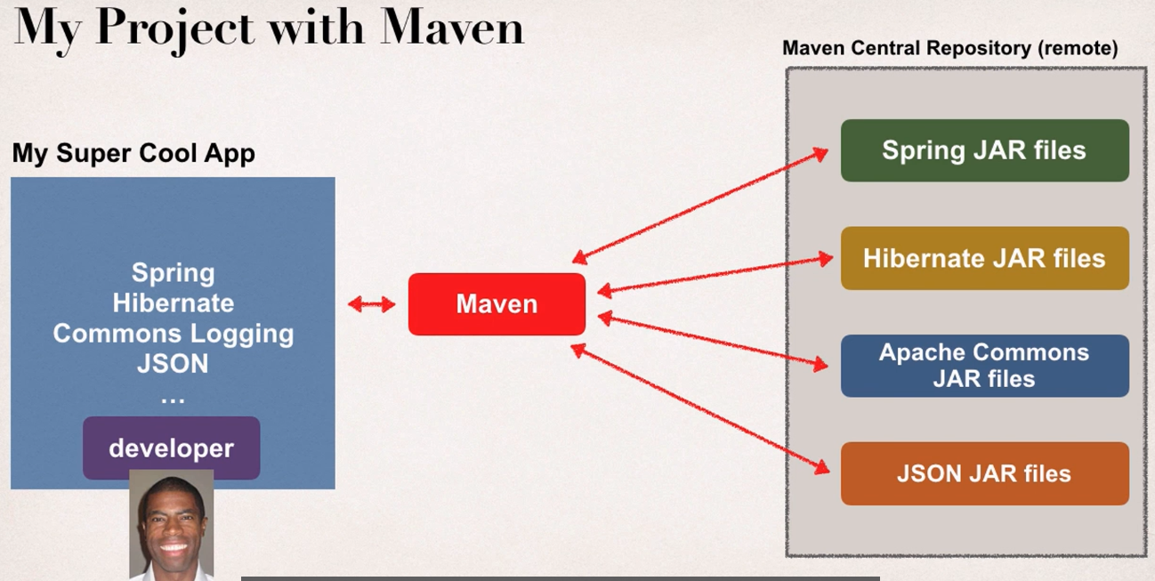

How it Works

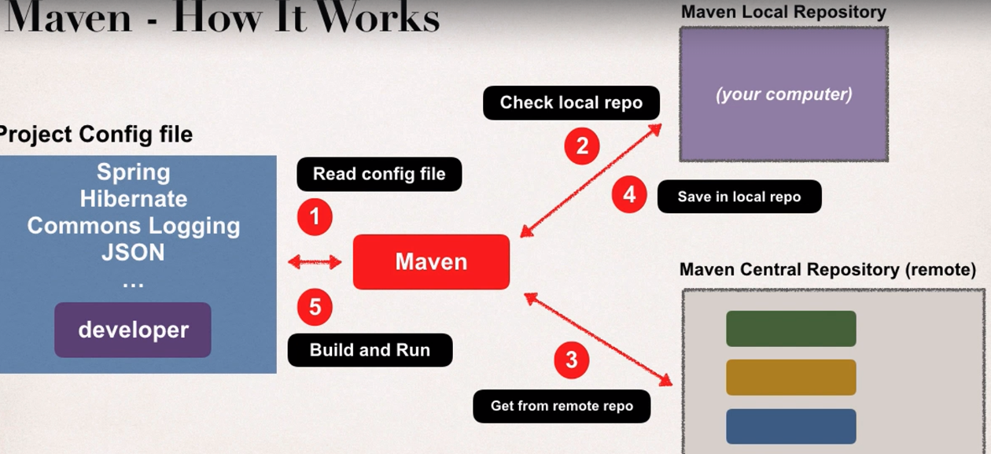

**Standard Directory Structure**

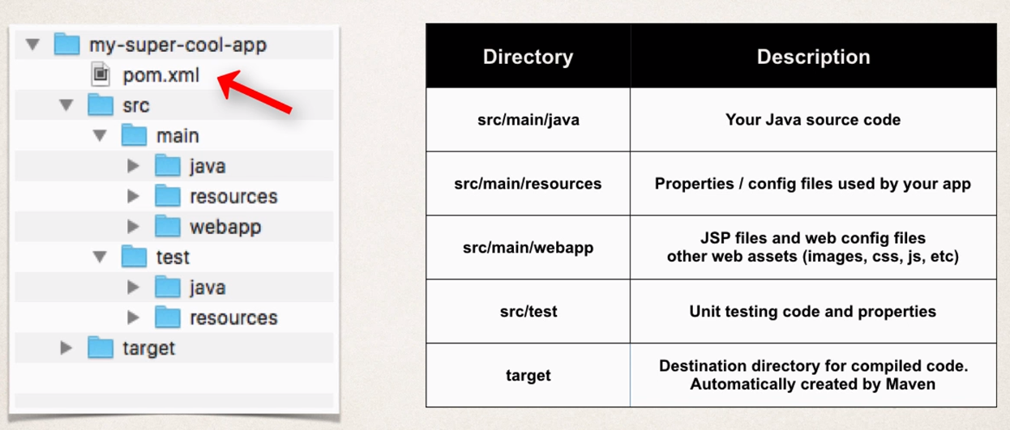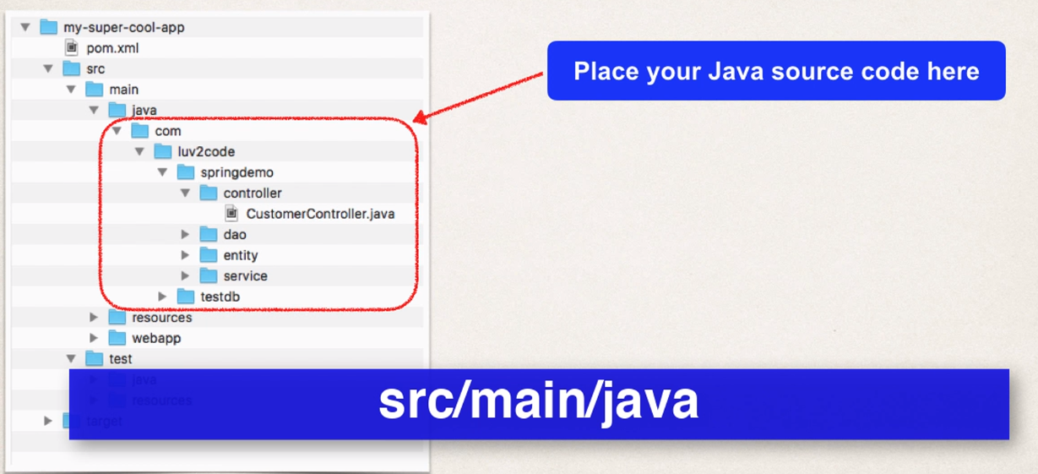

pom.xml is our maven

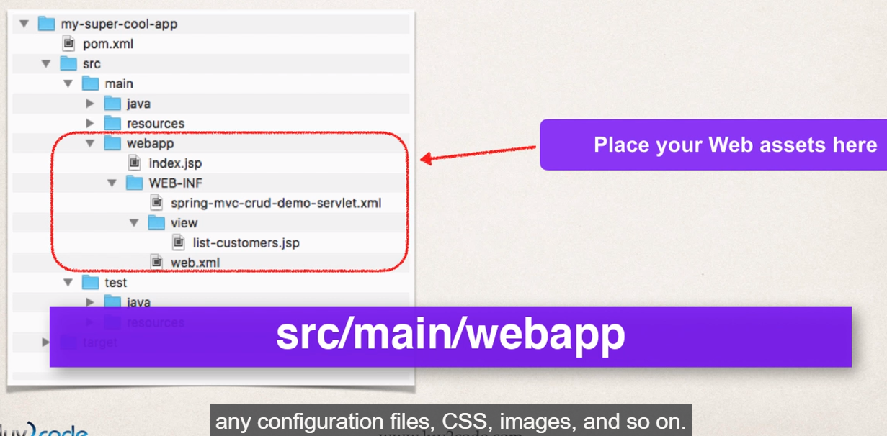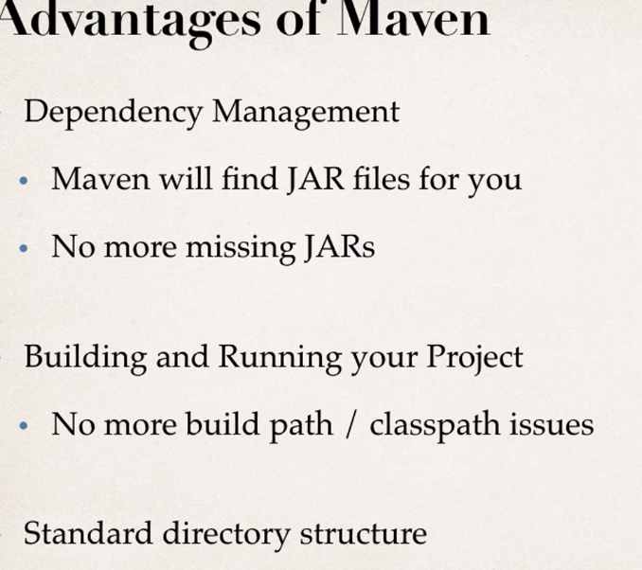

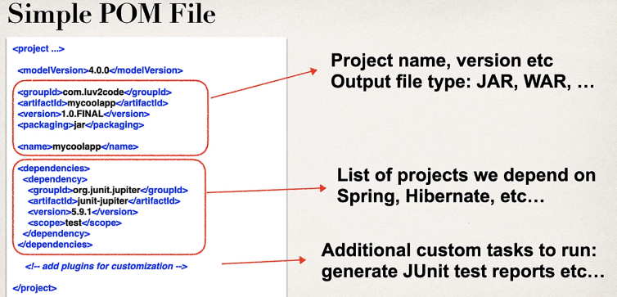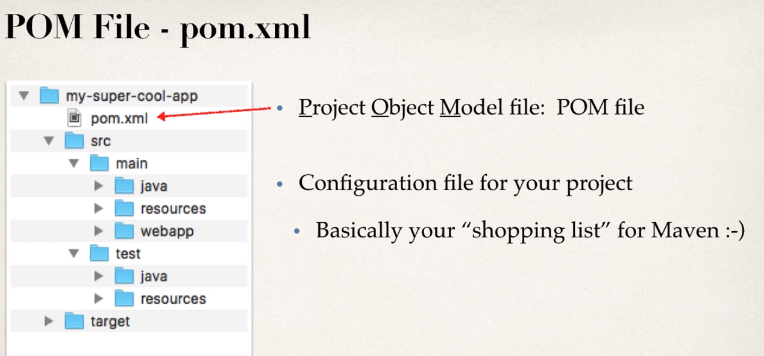

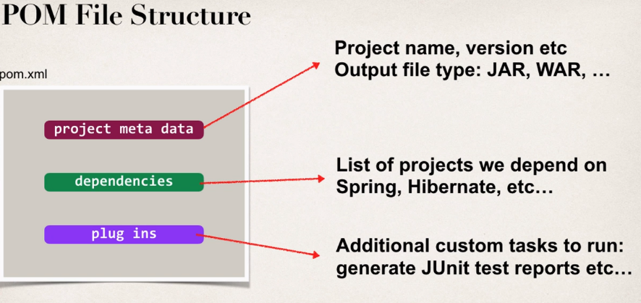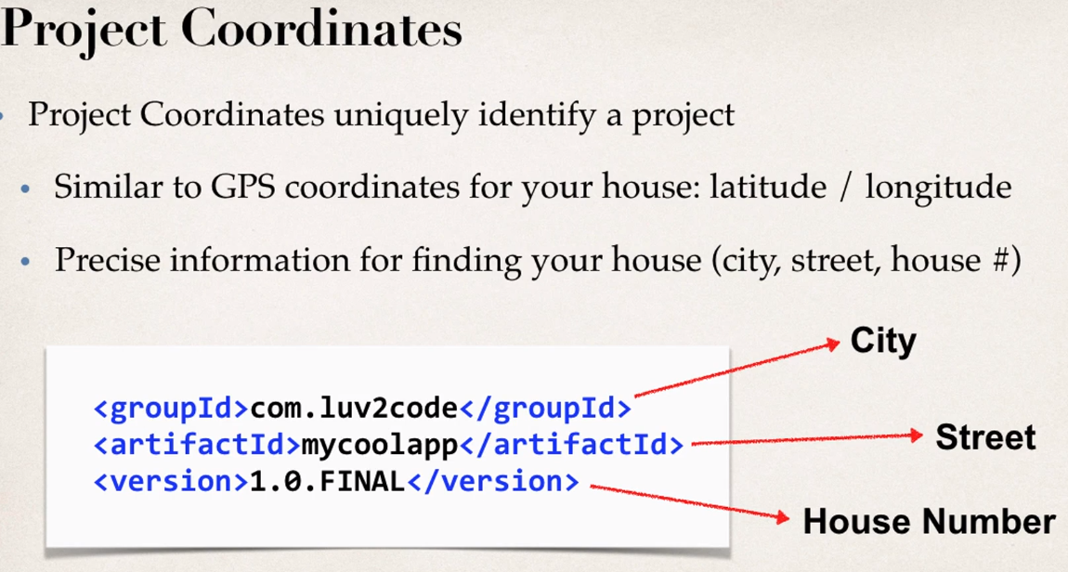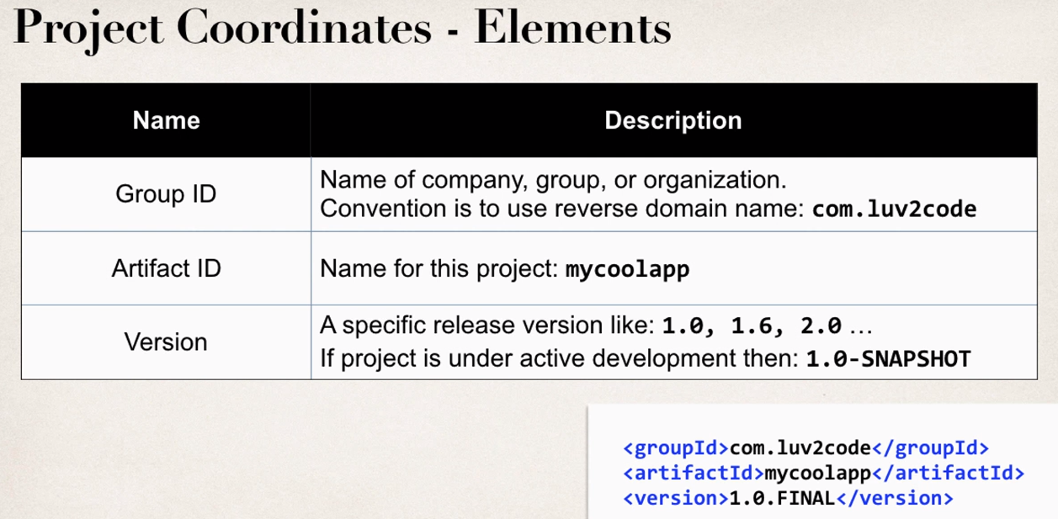

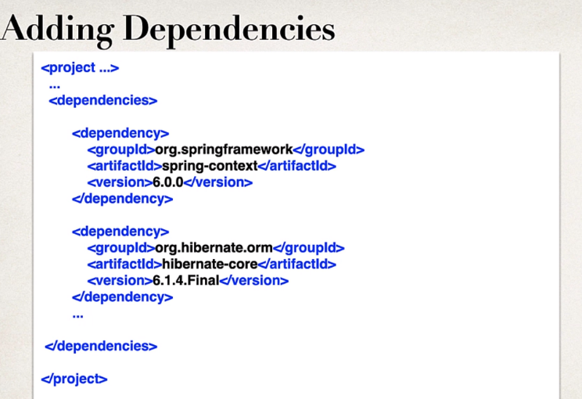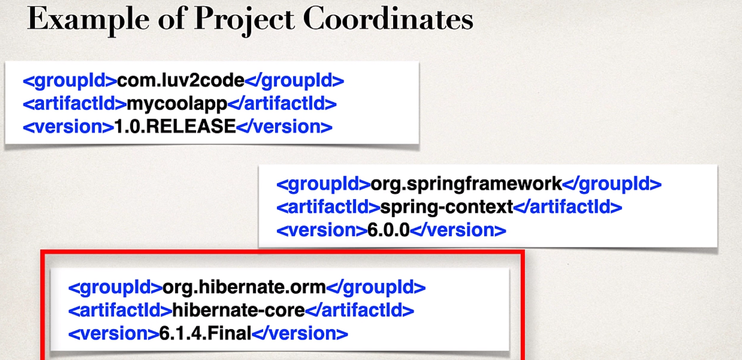

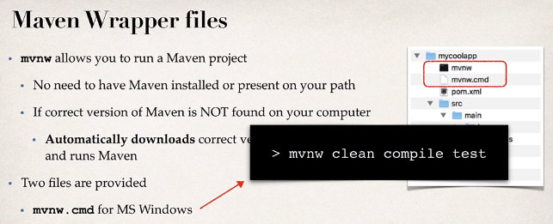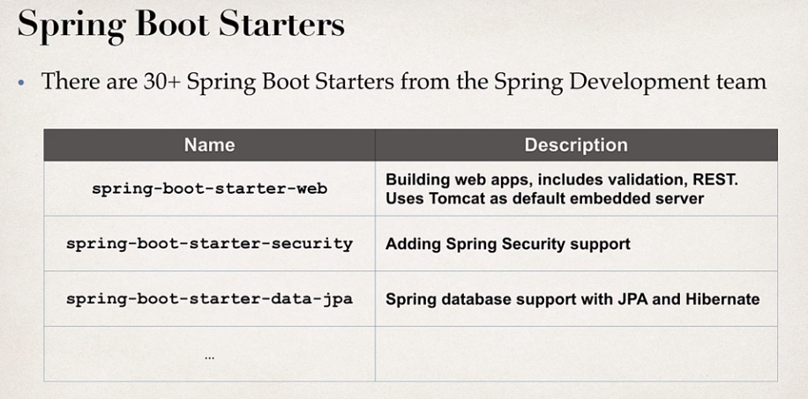

Spring-boot-dev tools will work to automatically update any changes in code.

Spring boot Actuator!

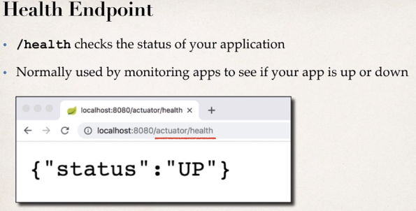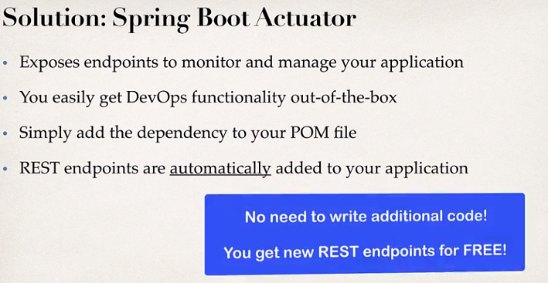

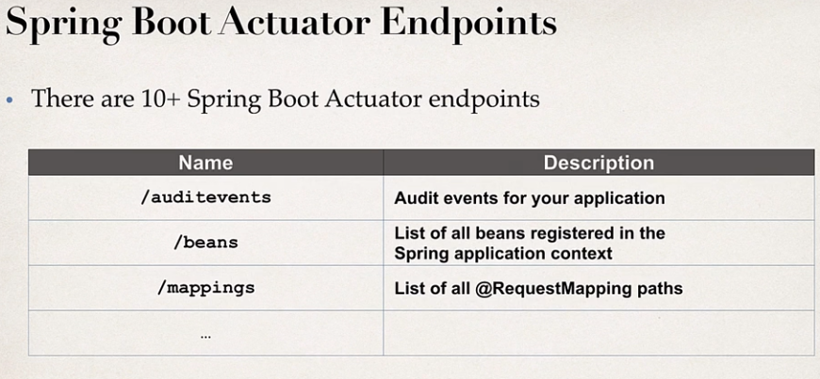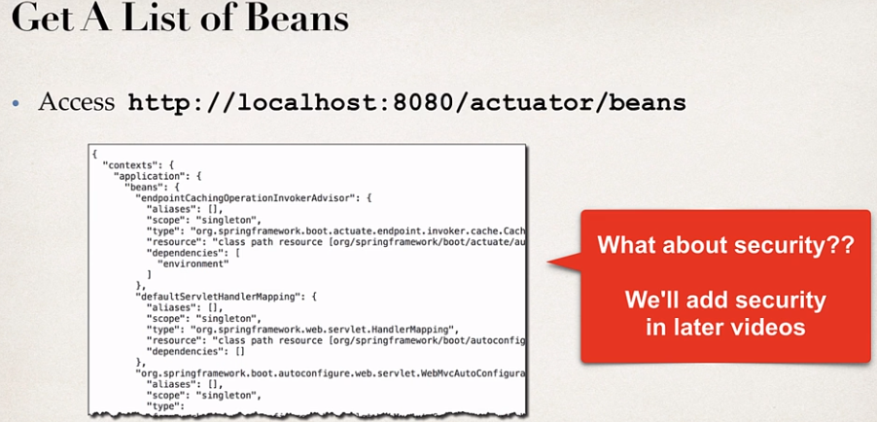

Actuator dev process

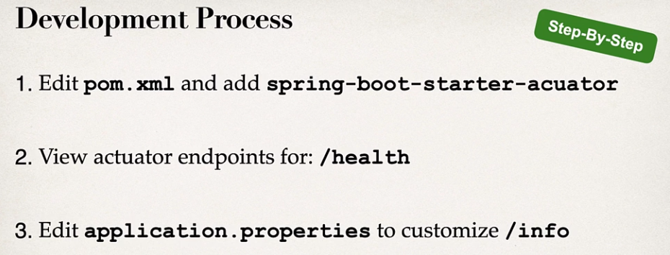

**Injecting Custom Application Properties**

**Problem**

* You need for your app to be configurable, no hard-coding of values
* You need to read app configuration from a properties file

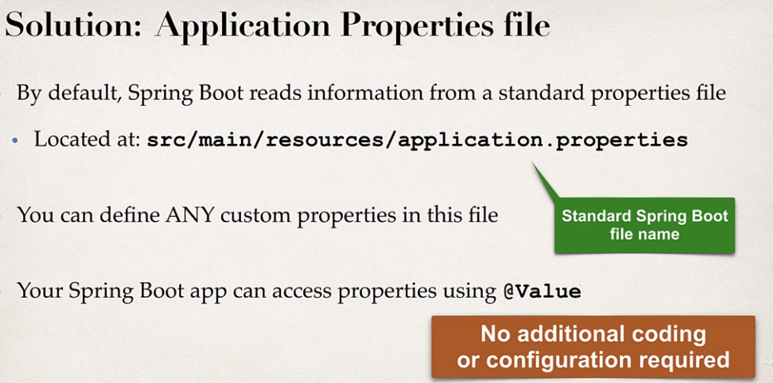

**Common Properties of Spring Boot Properties**

<https://docs.spring.io/spring-boot/docs/current/reference/html/application-properties.html#application-properties>

**Core Properties**

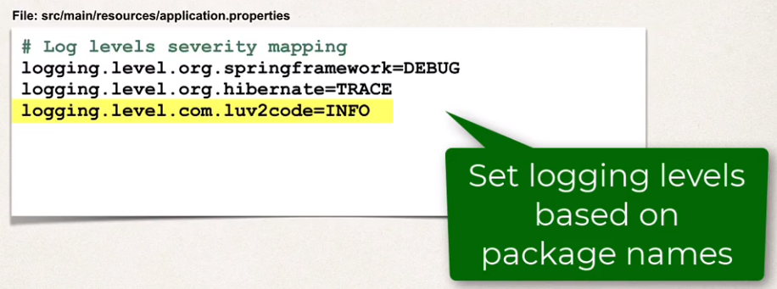

**Web Properties**

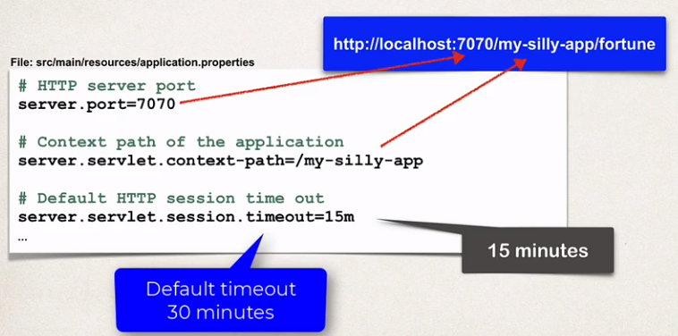

**Actuator**

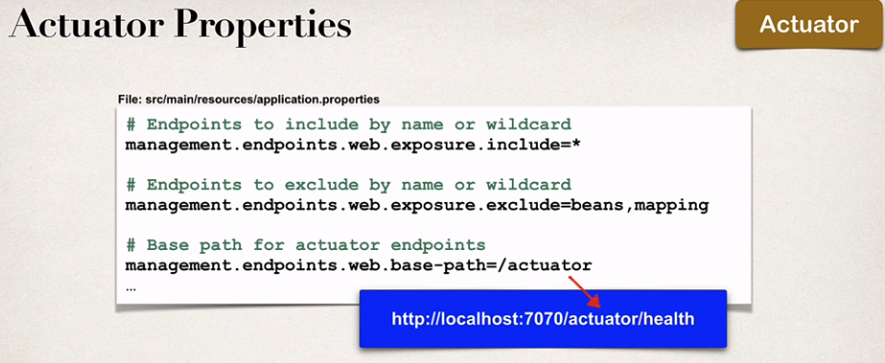

**Security Properties**

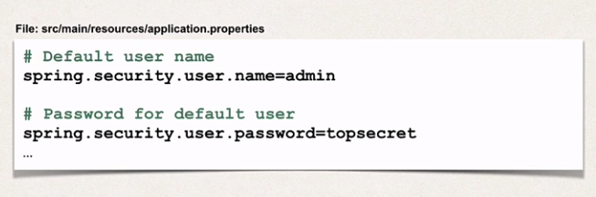

**Data Properties**

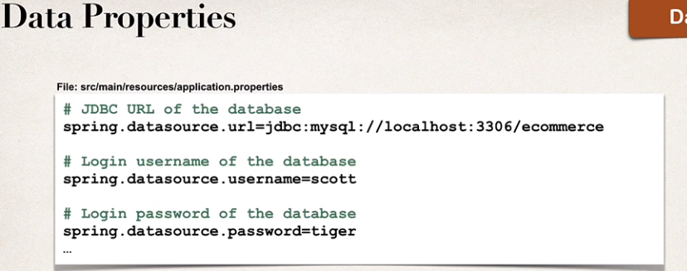

* **Inversion of Control (IoC)**

The approach of outsourcing the construction and management of objects.

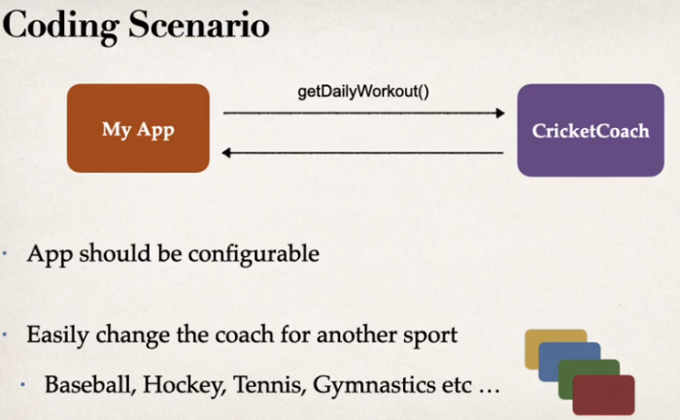from google*: is a software design principle that asserts a program can benefit in terms of pluggability, testability, usability and loose coupling if the management of an application's flow is transferred to a different part of the application.*

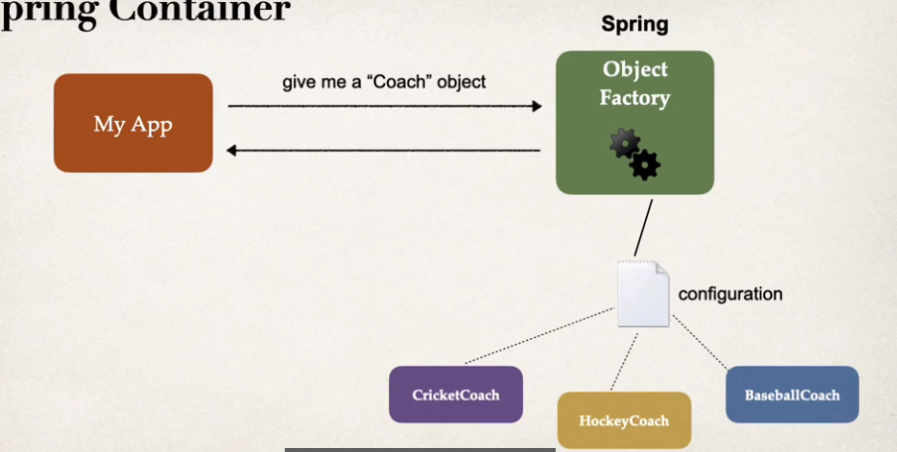

**Spring Container**

primary function of spring as object factory:

* Create and manage objects (Inversion of Control)
* Inject object dependencies (Dependency Injection)

Configuring Spring Container can be used with:

* XML Configuration file (legacy)
* Java Annotations
* Java Source Code
* **Dependency Injection**

The dependency inversion principle. The client delegates to another object the responsibility of providing its dependencies.

the idea :

*Give me a given object, if it has any components or helper components, then assemble all that for me ahead of time and simply give it to me so I can use it out of the box.*

Example:

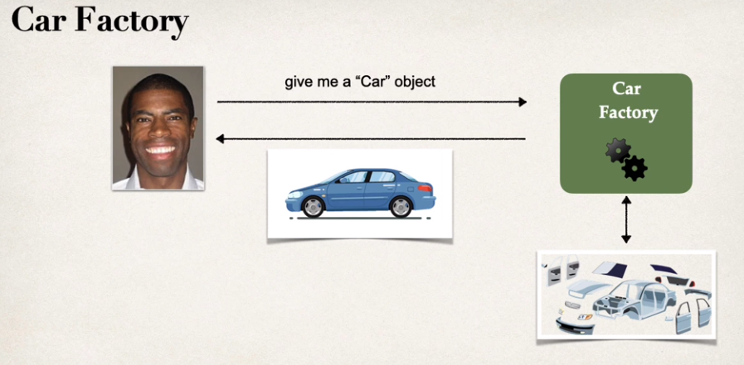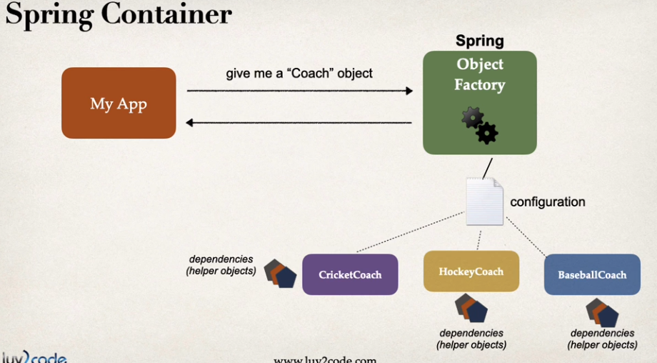

Dependency Injection is **a fundamental aspect of the Spring framework**, through which the Spring container “injects” objects into other objects or “dependencies”.

Simply put, this allows for loose coupling of components and moves the responsibility of managing components onto the container.

<https://www.baeldung.com/inversion-control-and-dependency-injection-in-spring>

**Injection Types**

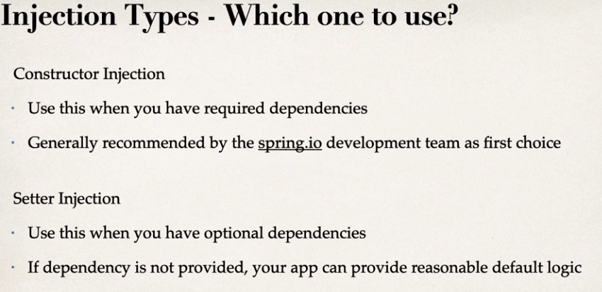

**Spring AutoWiring**

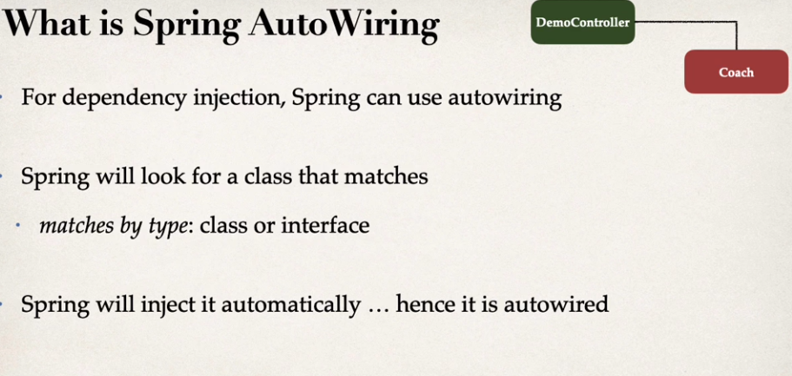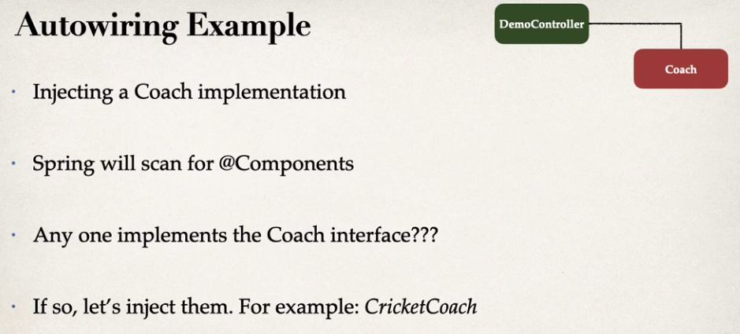

**# Component Scanning**

Spring will scan your Java classes for special annotations (@Component, etc...) and it will automatically register the beans in the Spring container.

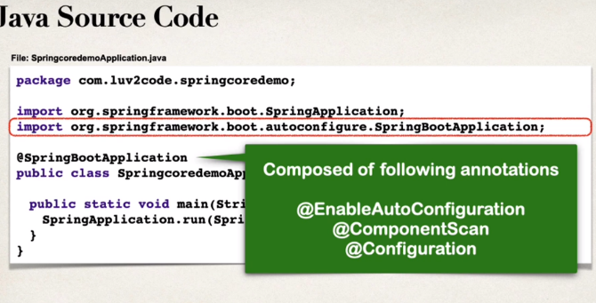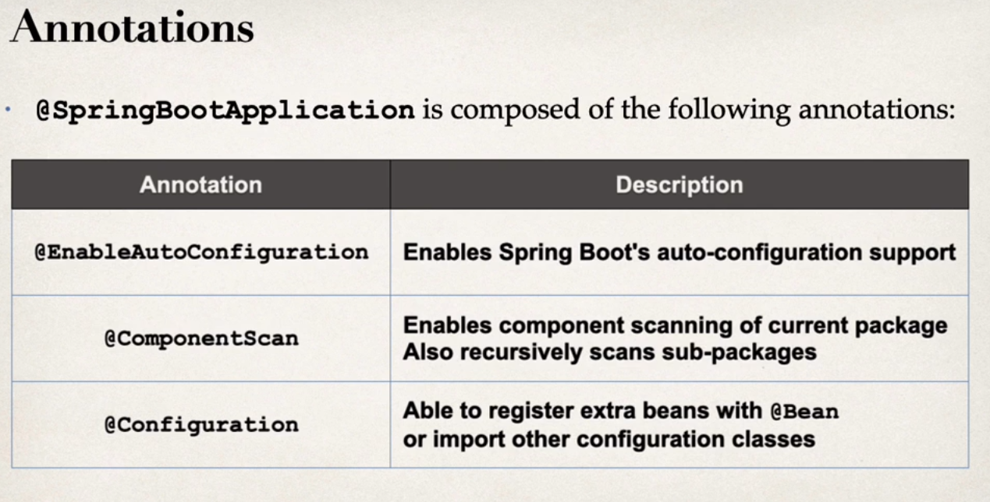

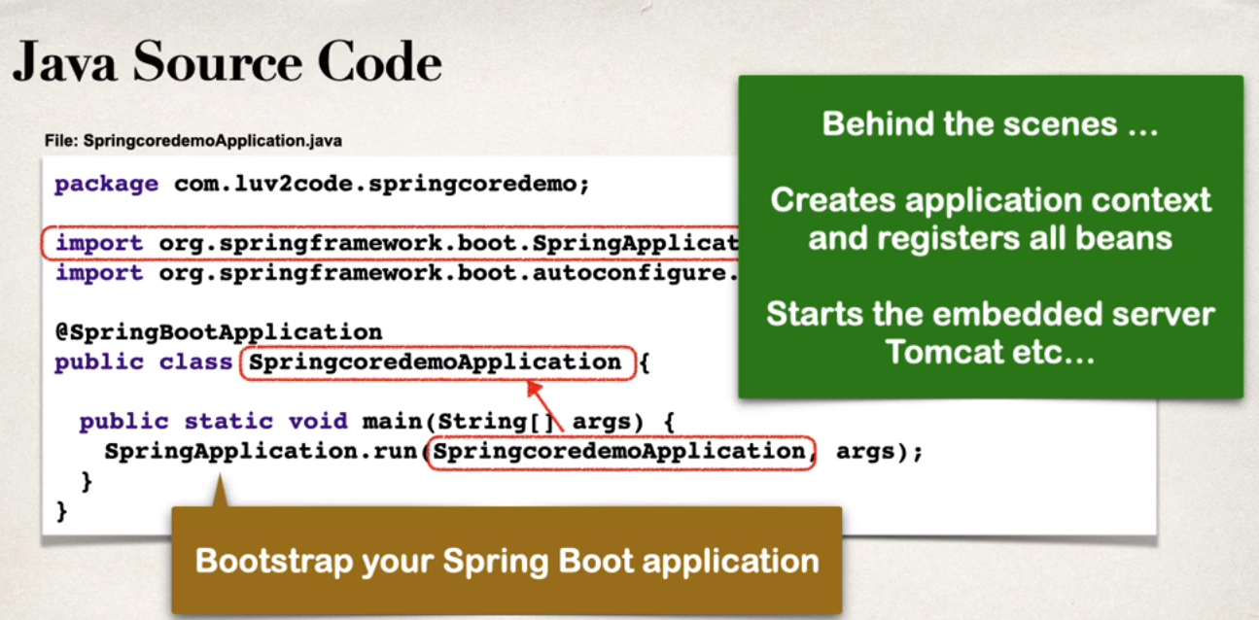

By default, Spring Boot starts component scanning:

* + from same package as your main Spring Boot app
  + Also scans sub-packages recursively

This implicitly defines a base search package

* + Allows you to leverage default component scanning
  + 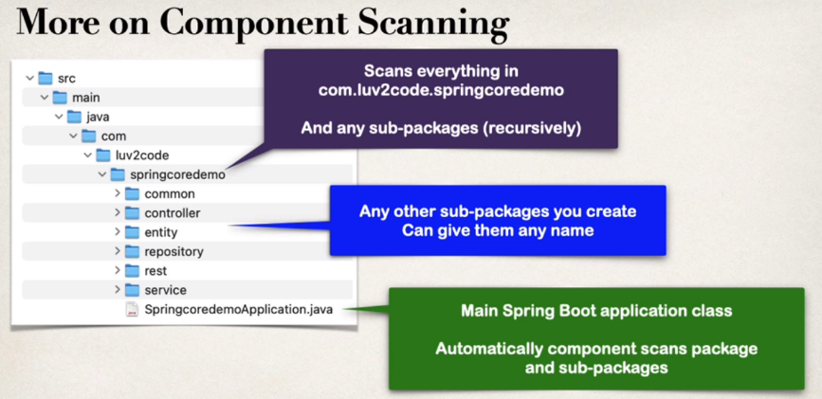no need to explicitly reference the base package name

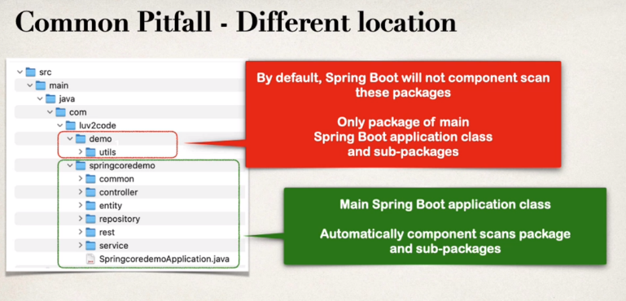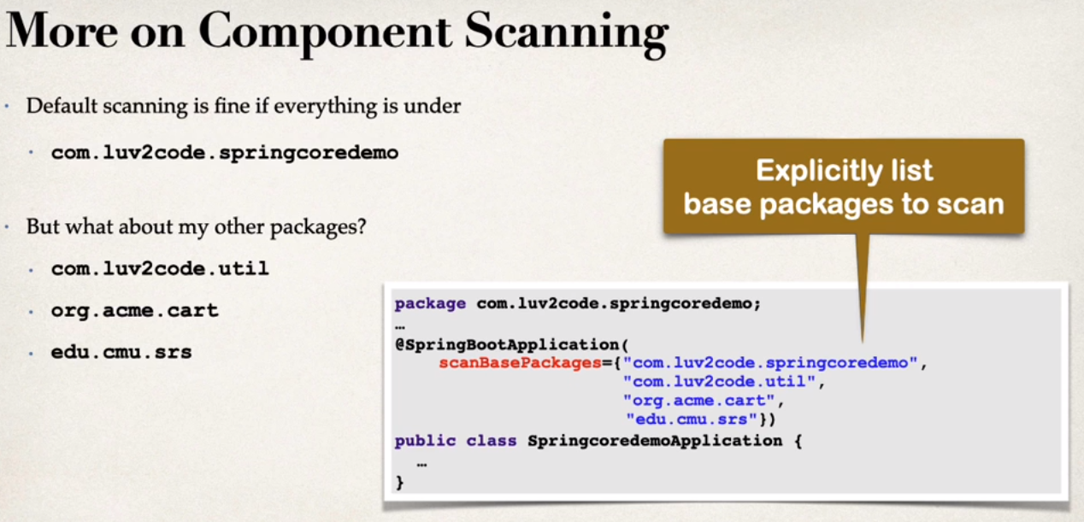

**# Setter Injection**

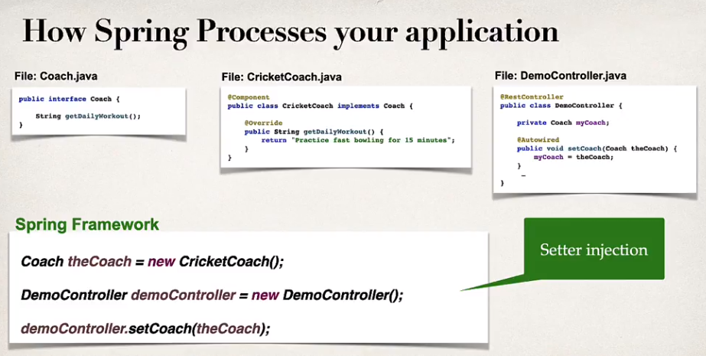

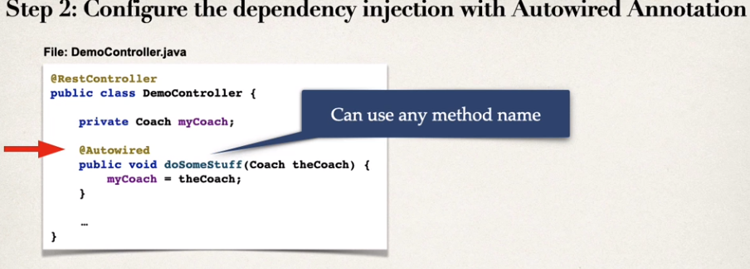

Injection types – which one to use?

* + Constructor Injection :> use this when you have a required dependencies. Generally recommended by the spring.io dev team as first choice
  + Setter Injection :> use this when you have optional dependencies. If it is not provided, your app can provide reasonable default logic.

**# Field Injections**

**Not recommended by the spring.io dev team**

it makes the code harder to unit test! but it’s used in the old times.

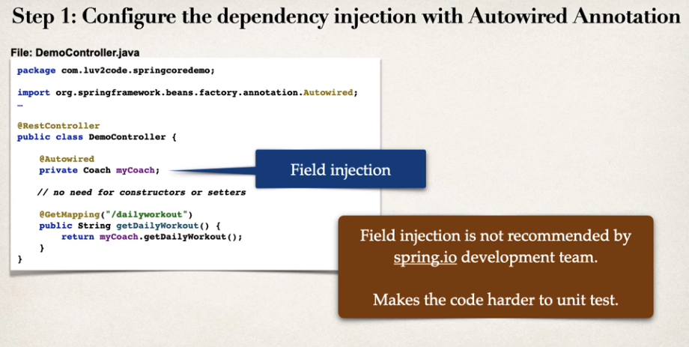

**# Qualifiers**

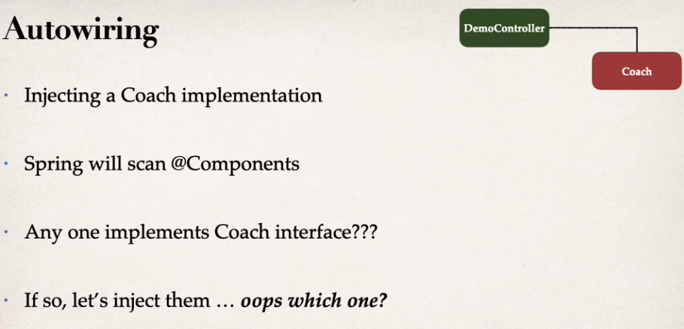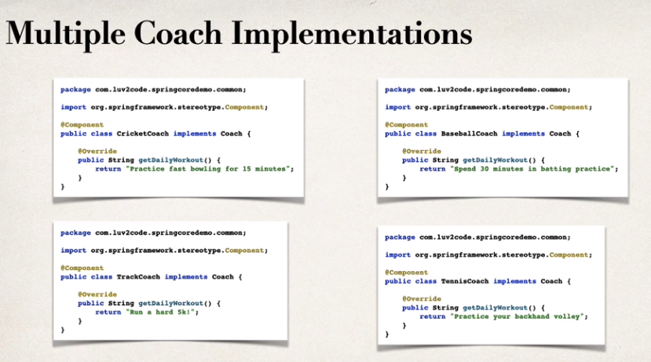

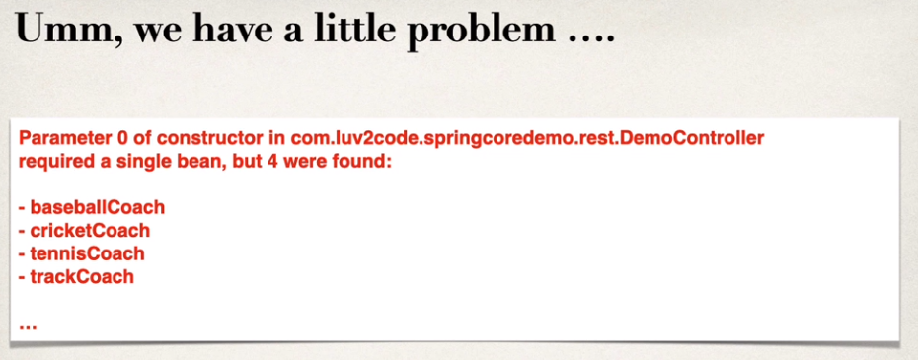

use @Qualifier can make it specific!

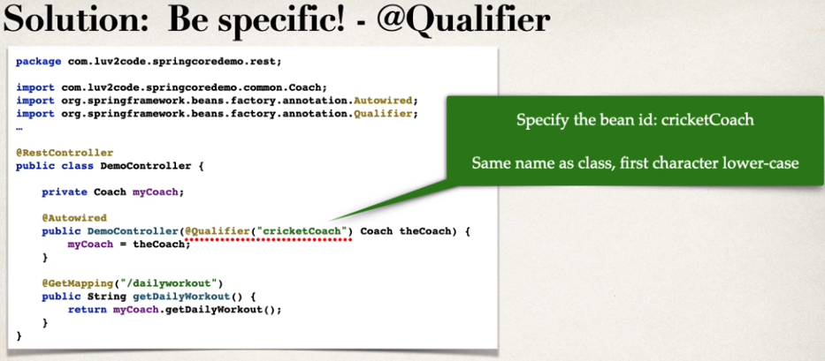

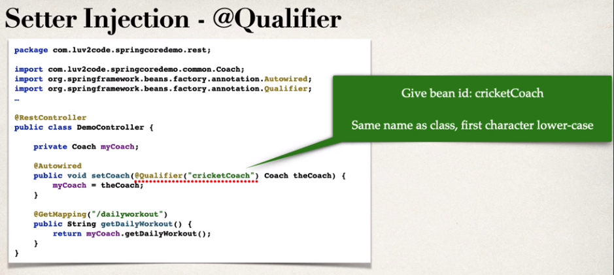

**# Primary Annotations**

Used to “stamp” who is the primary, so when we call it on constructor, the class that has primary annotation will be the one that is called.

WE can also mix qualifier and primary, but qualifier has the higher priority!

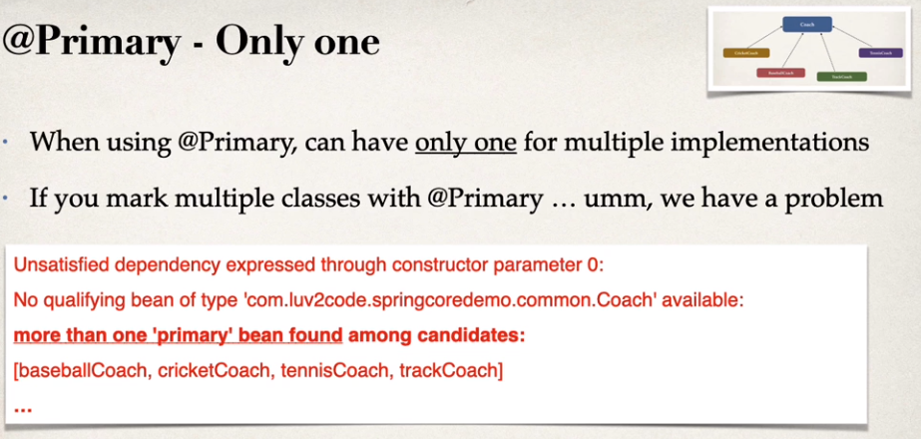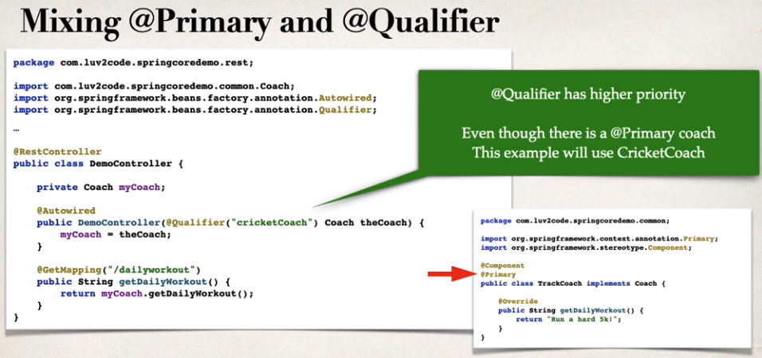

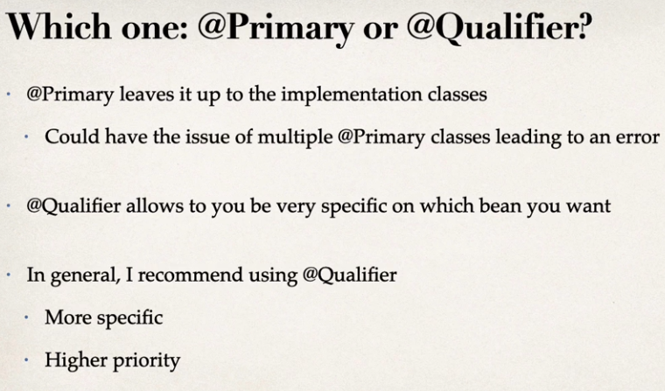

**# Lazy Initialization**

Instead of creating all beans up front, we can specify lazy initialization

A bean will only be initialized in the following cases:

* + It is needed for dependency injection
  + Or it is explicitly requested

Add the @Lazy annotation to a given class

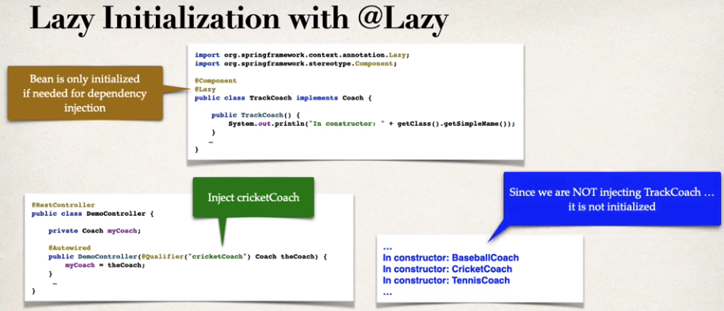

We can initialise the Lazy in global configuration!

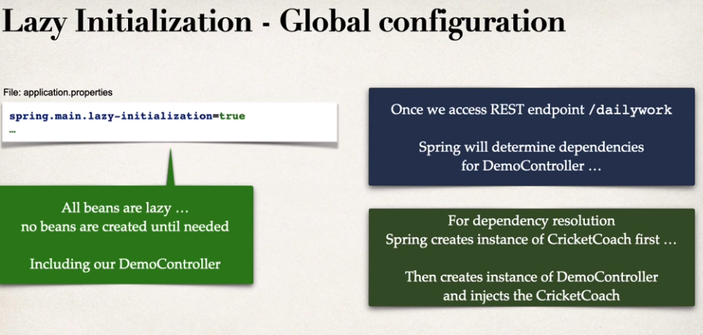

advantages:

* + Only create objects as needed
  + May help with faster startup time if you have large number of components

disadvantages:

* + If you have web related components like @RestController, not created until requested
  + May not discover configuration issues until too late
  + Need to make sure you have enough memory for all beans once created
  + 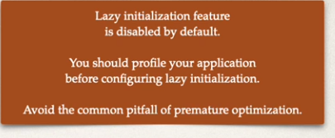

**# Bean Scope**

Default scope of bean is singleton. What is that?

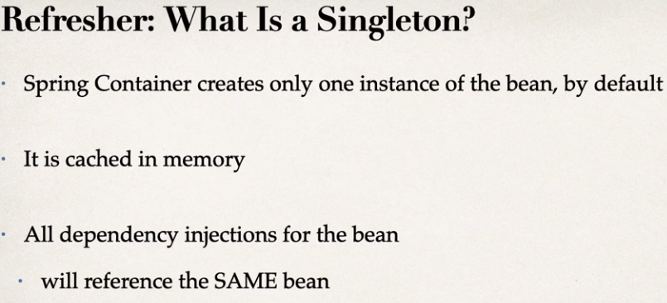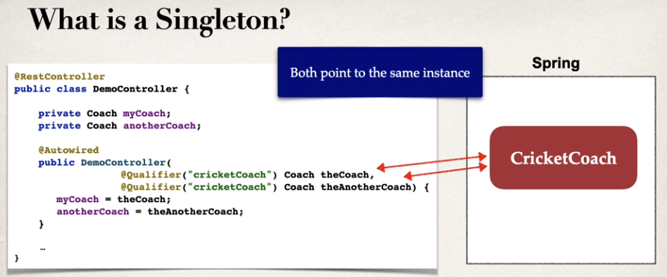

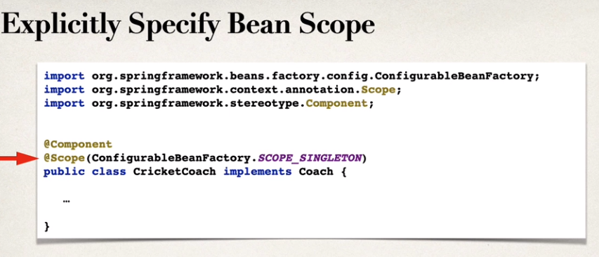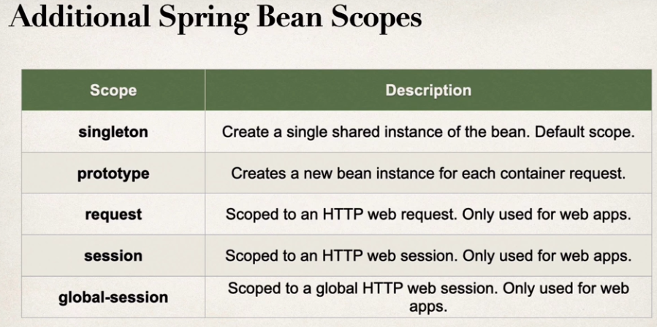

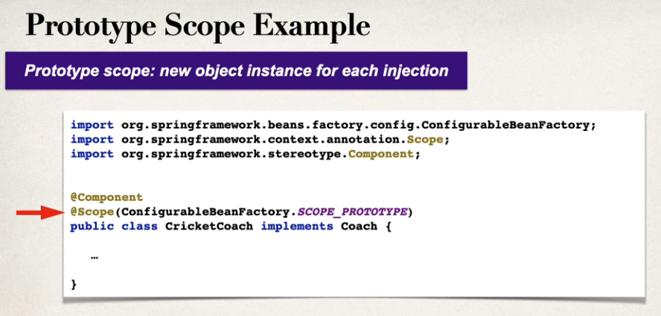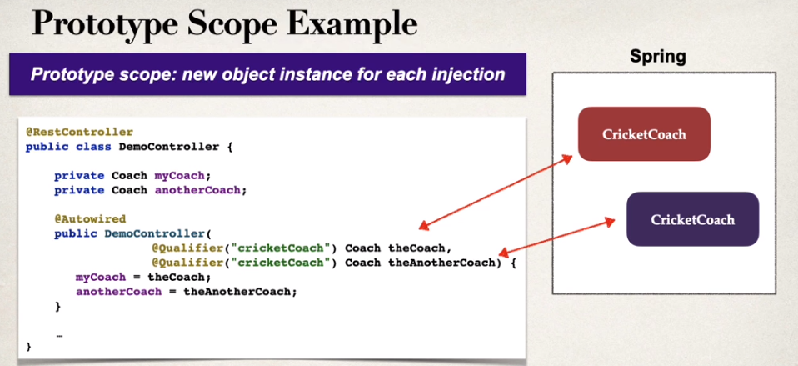

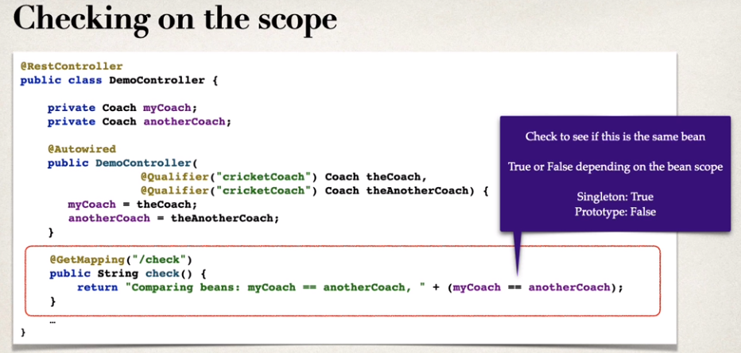

**# Bean Lifecycle Methods**

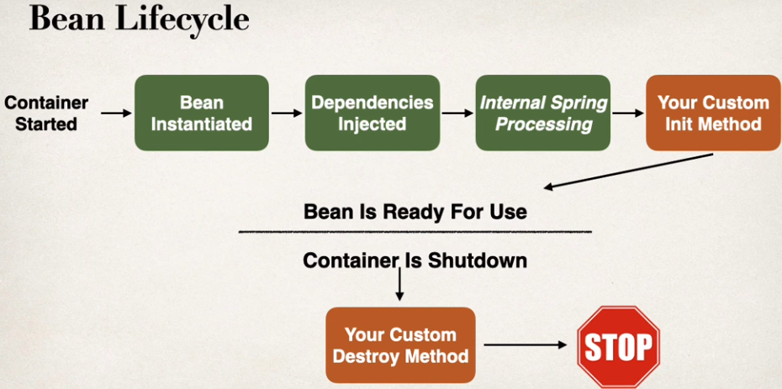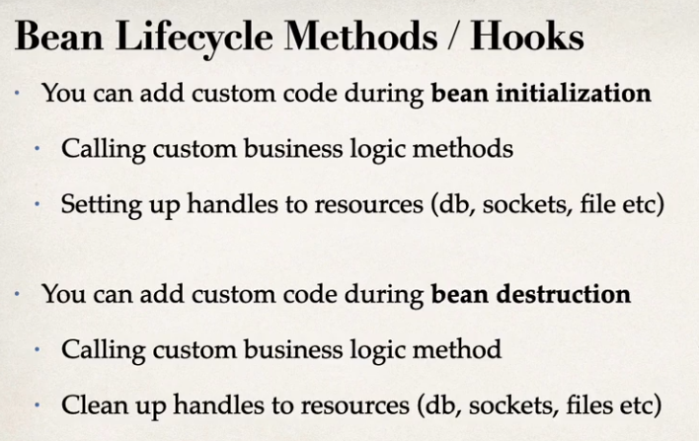

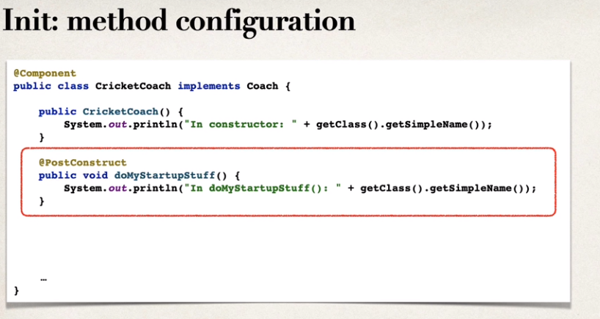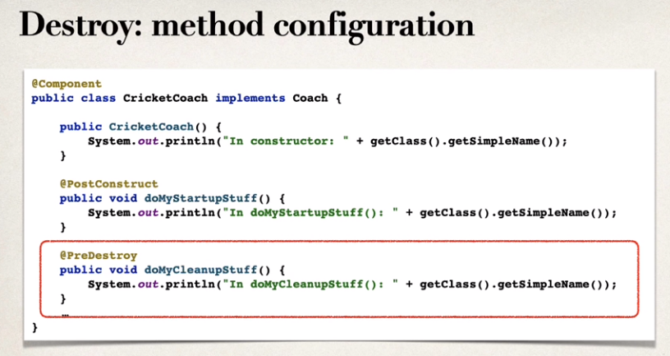

#### Special Note about Prototype Scope - Destroy Lifecycle Method and Lazy Init

#### **Prototype Beans and Destroy Lifecycle**

There is a subtle point you need to be aware of with "prototype" scoped beans.

**For "prototype" scoped beans, Spring does not call the destroy method. Gasp!**

---

**In contrast to the other scopes, Spring does not manage the complete lifecycle of a prototype bean**: the container instantiates, configures, and otherwise assembles a prototype object, and hands it to the client, with no further record of that prototype instance.

Thus, although initialization lifecycle callback methods are called on all objects regardless of scope, **in the case of prototypes, configured destruction lifecycle callbacks are not called**. The client code must clean up prototype-scoped objects and release expensive resources that the prototype bean(s) are holding.

#### **Prototype Beans and Lazy Initialization**

Prototype beans are lazy by default. There is no need to use the @Lazy annotation for prototype scopes beans.

**# Java Config Bean**

Use case for @Bean

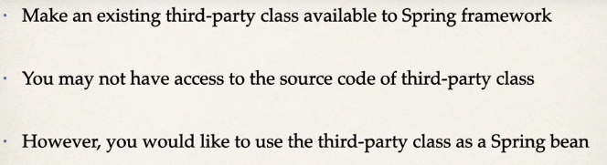

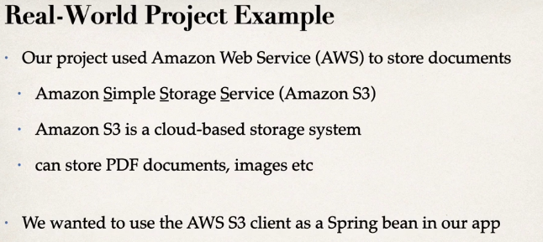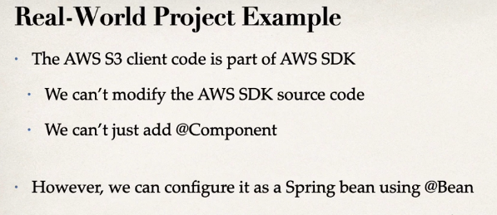

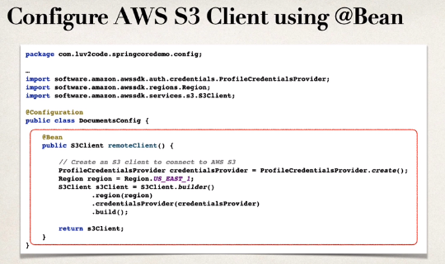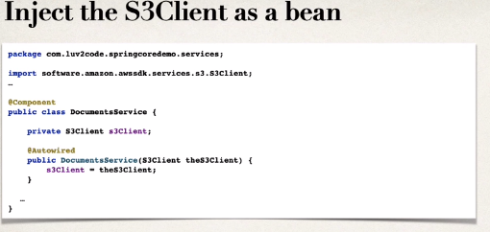

when we use Bean annotation, we can use that bean to other class.

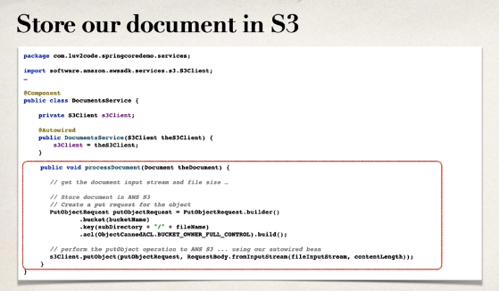

**Spring Hibernate/JPA**

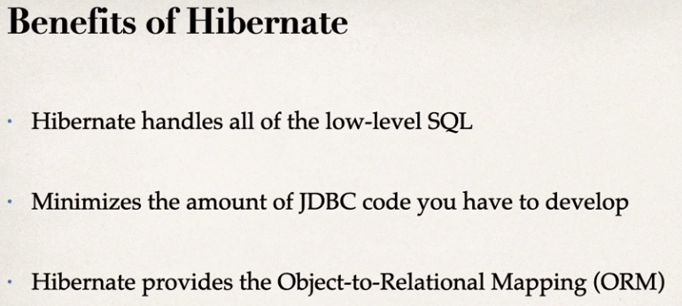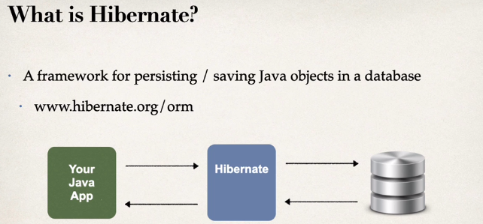

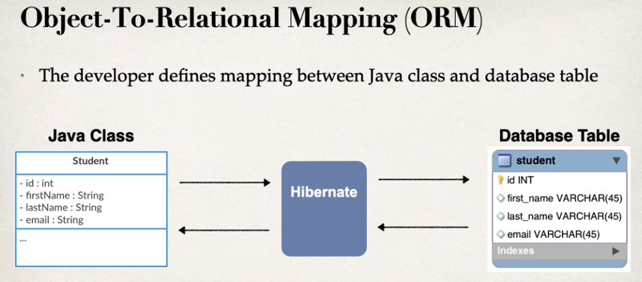

**JPA**

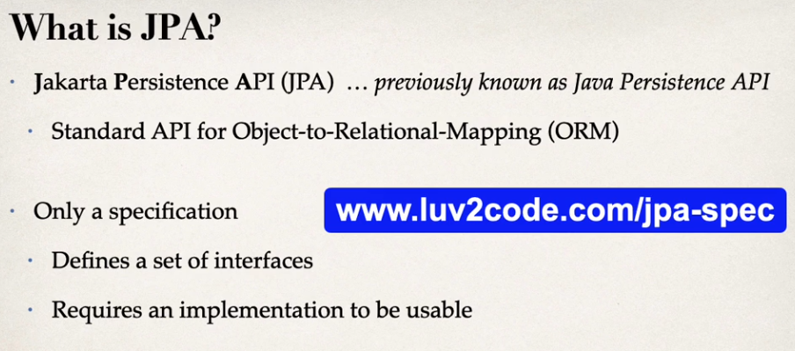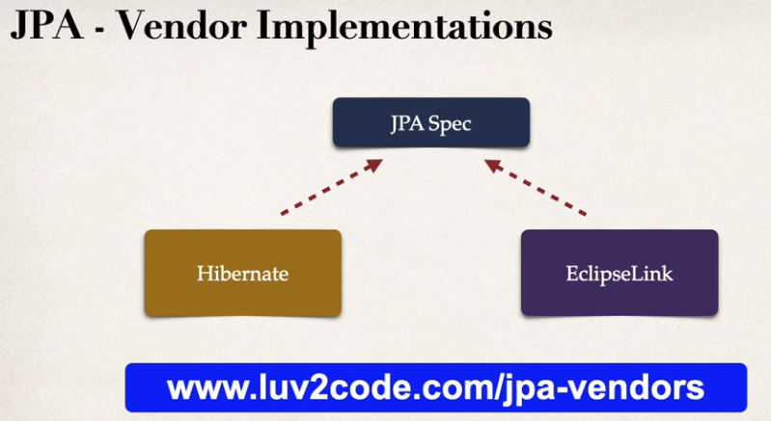

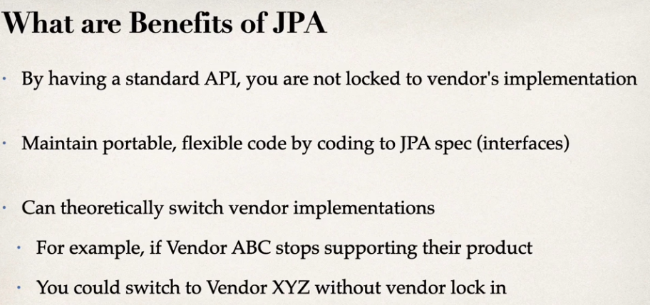

Saving and Retrieving a Java Object with JPA

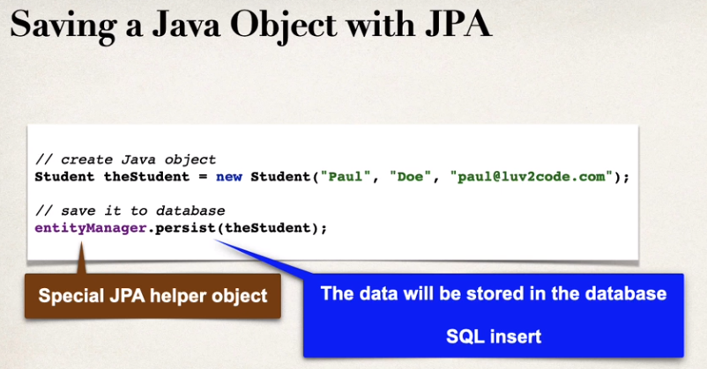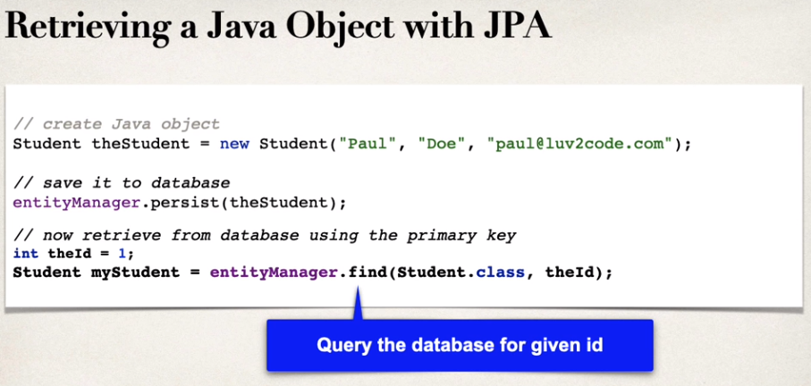

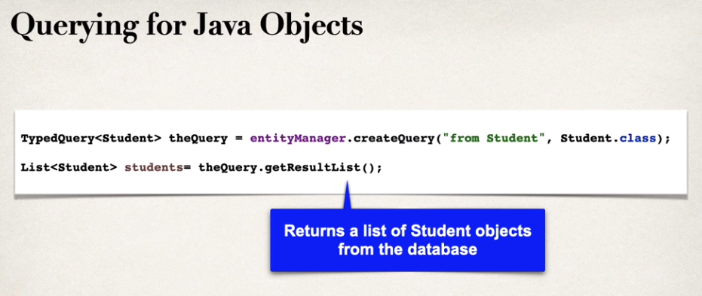

How does hibernate / JPA relate to JDBC?

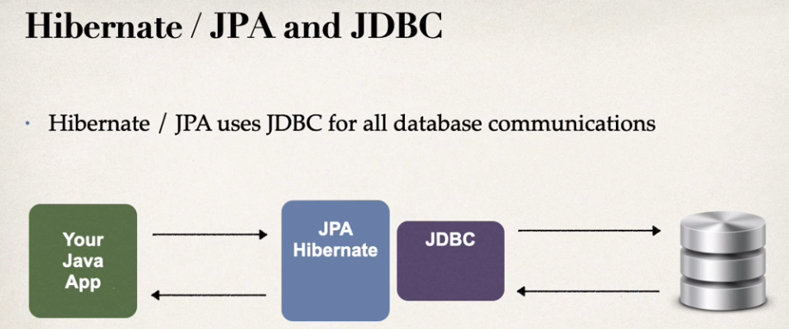

Hibernate make used of JDBC in the background.

**# Automatic Data Source Configuration**

In spring boot, hibernate is the default implementation of JPA. EntityManager is main component for creating queries etc.. , and it is from Jakarta Persistence API (JPA) 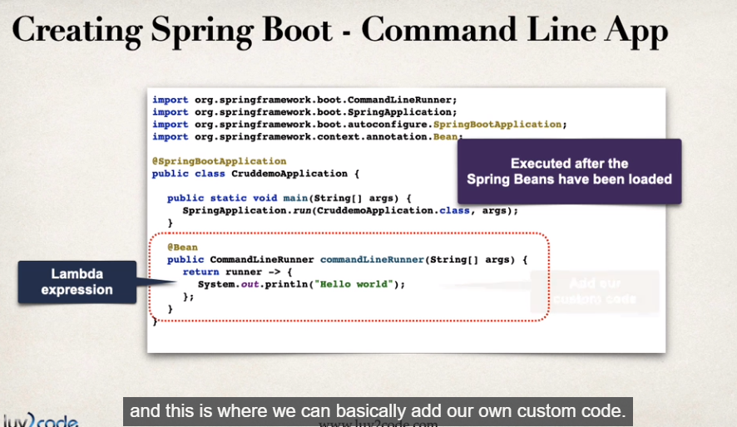

**# JPA Annotations**

* + Entity Class: a Java class that is mapped to a database table

It must be annotated with **@Entity**. It also must have a public or protected no-argument constructor. the class can have other constructors.

With Java annotations, there’s a two step we are going to do when using JPA.

1. Map class to database table

2. Map fields to database columns

**Map class to database table**

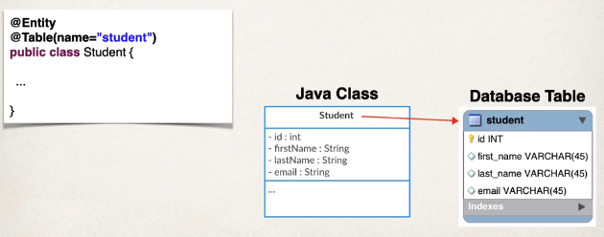

**Map fields to database columns**

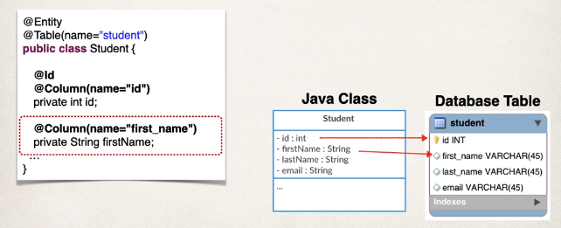

@Column is actually optional, if we don’t specified the column name, the column name is the same name as Java field. BUT THIS IS NOT RECOMMENDED!

* + Primary Key

Uniquely identifies each row in a table. Must be a unique value and cannot contain NULL values!

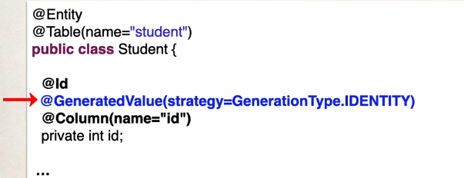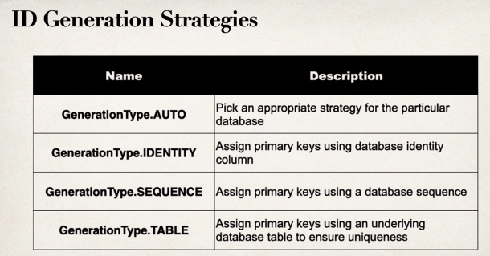

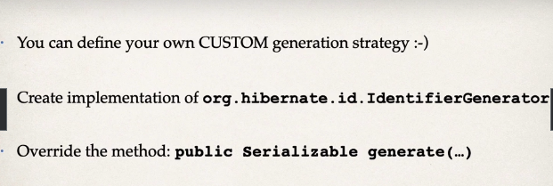

**Data Access Object**

[*DAO DESIGN PATTERN*](https://www.digitalocean.com/community/tutorials/dao-design-pattern)

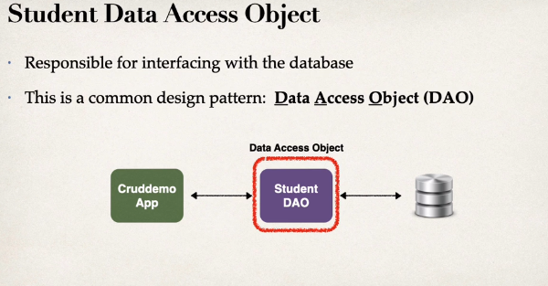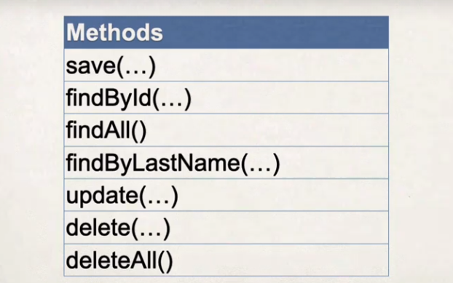

**Student DAO** is like a helper class for communicating with the database. Our DAO needs a JPA entity manager. **JPA Entity Manager** is the main component for saving/retrieving entities.

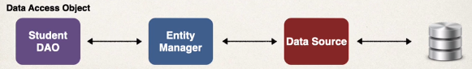

Our JPA Entity Manager needs a **Data Source**. The Data Source defines database connection info. JPA Entity Manager and Data Source are automatically created by Spring Boot, based on the data inside the application.properties, such as JDBC URL, user id, password, etc, it actually connect to the database. We can autowire/inject the JPA Entity Manager into our student DAO

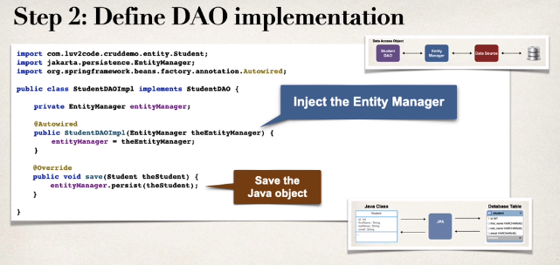

**Spring @Transactional**

spring provides an @Transactional annotation. It’s used to Automagically begin and eng a transaction for your JPA code, and we don’t need to explicitly do this in our code. This spring magic happens behind the scenes.

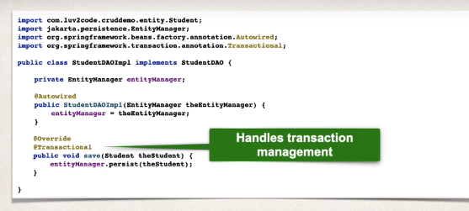

**Specialized Annotation for DAOs**

**@Repository**

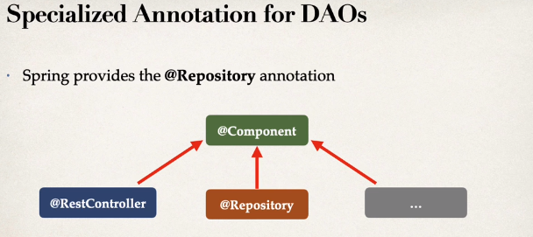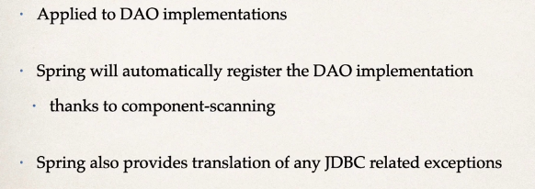

is a specialization of @Component annotation which is used to indicate that the class provides the mechanism for storage, retrieval, update, delete and search operation on objects. This annotation is a general-purpose stereotype annotation which very close to the [DAO pattern](https://www.geeksforgeeks.org/data-access-object-pattern/) where DAO classes are responsible for providing CRUD operations on database tables.

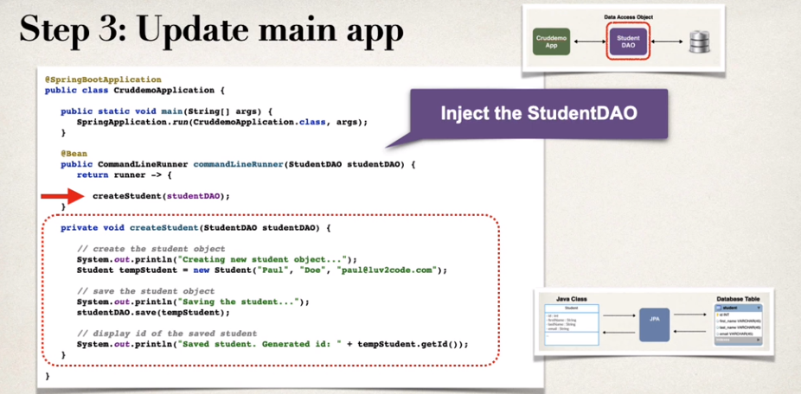

**Retrieving a Java Object with JPA**

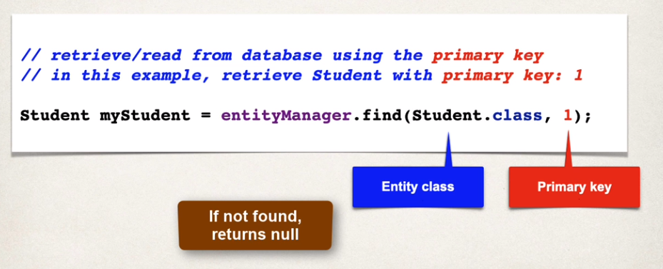

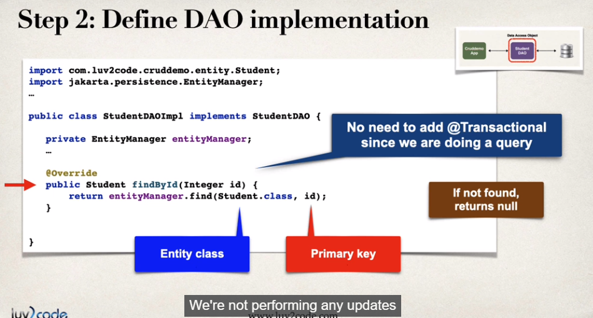

**Querying Objects with JPA**

**# JPA Quety Language (JPQL)**

it is a query language to retrieving objects. Its concept is similar to SQL (where, like, order by, etc). However, JPQL is based on **entity name** and **entity fields.**

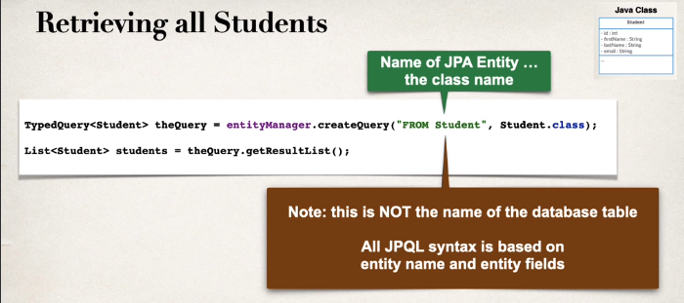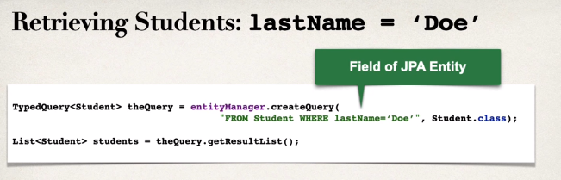

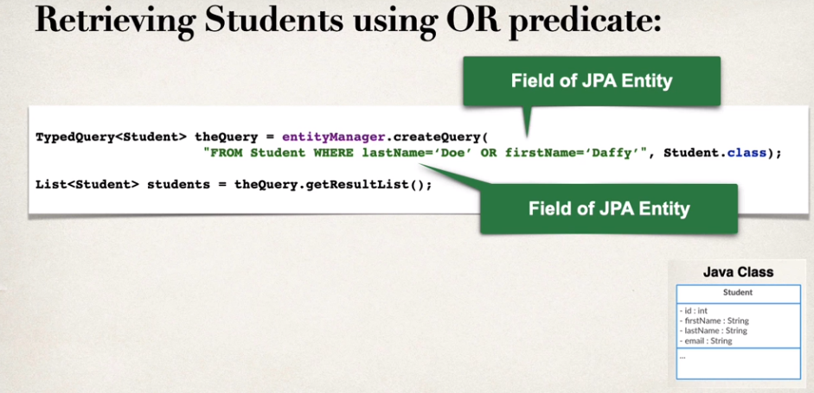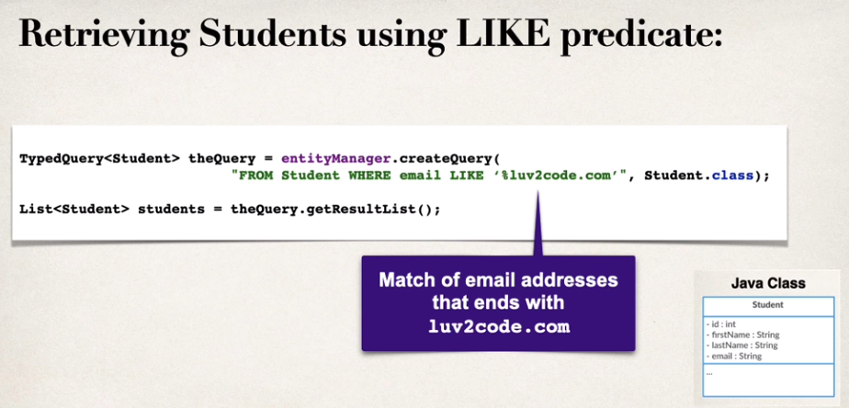

**JPQL – Named Parameters**

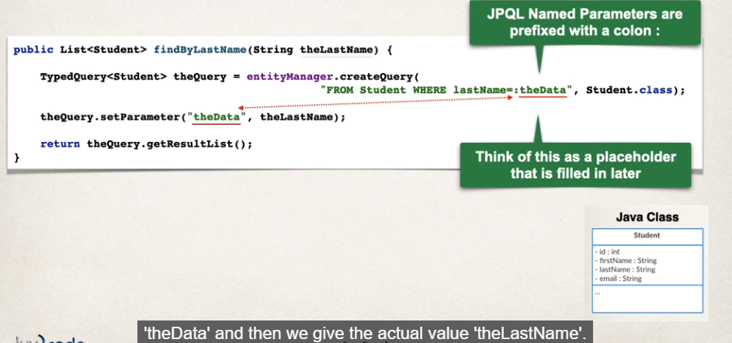

**Update an Object**

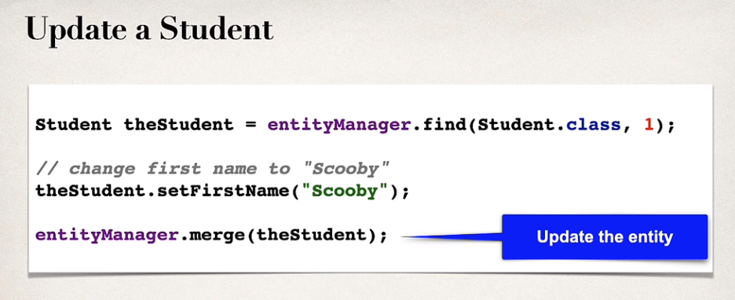

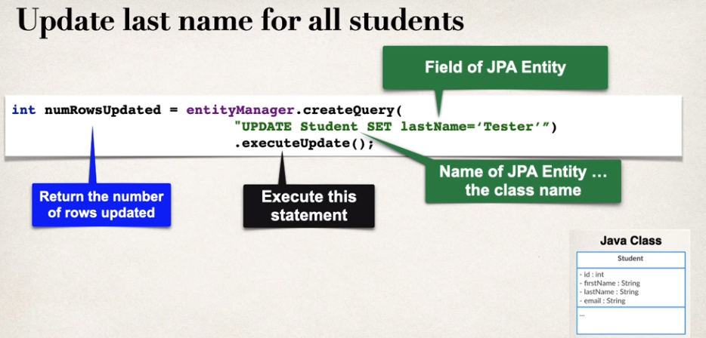

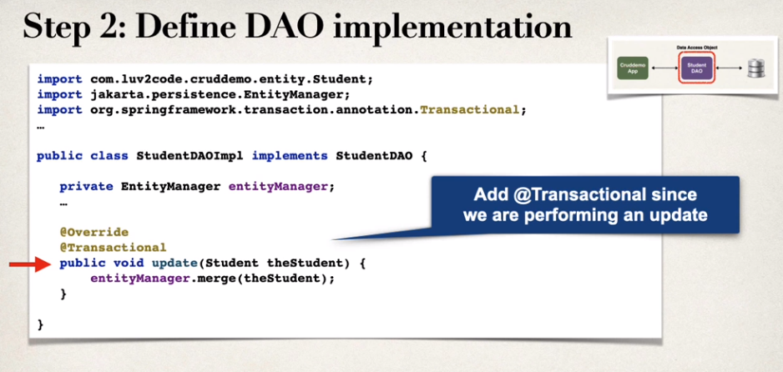

**Delete an Object**

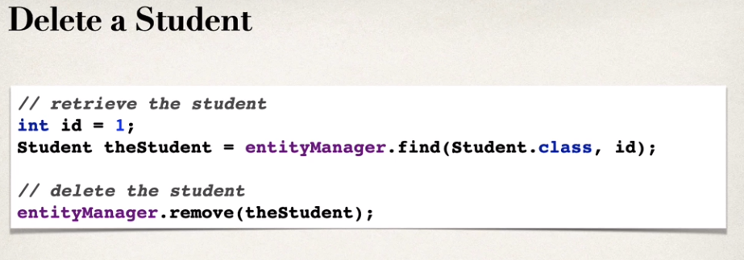 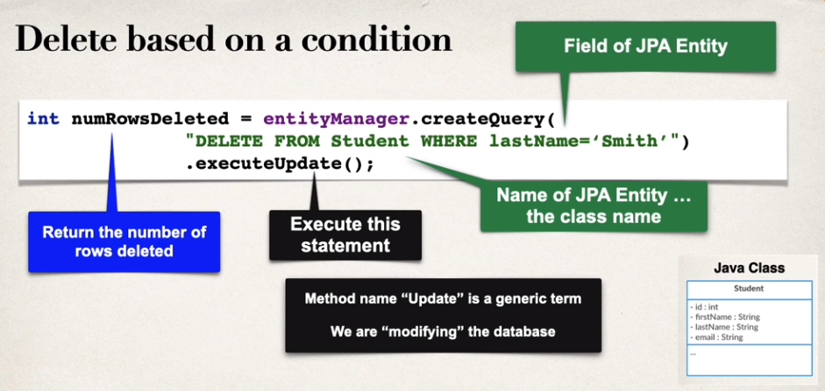

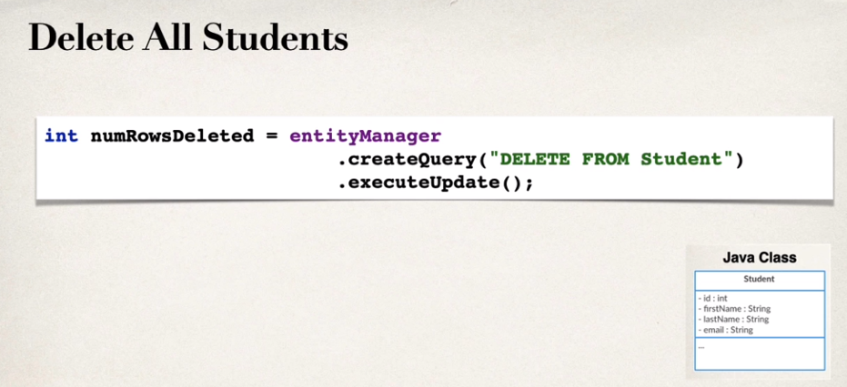

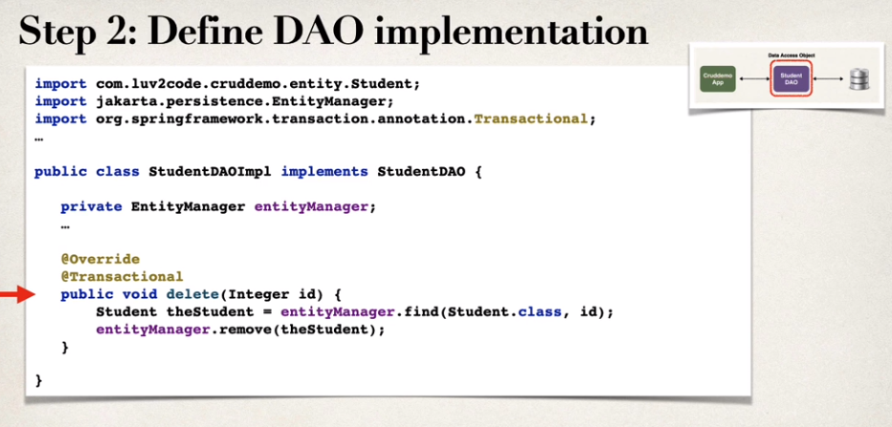

**Create database tables on Java code with JPA/Hibernate annotations**

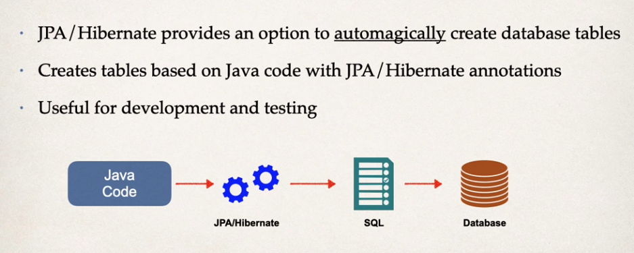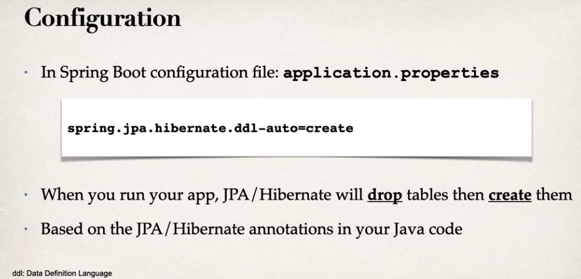

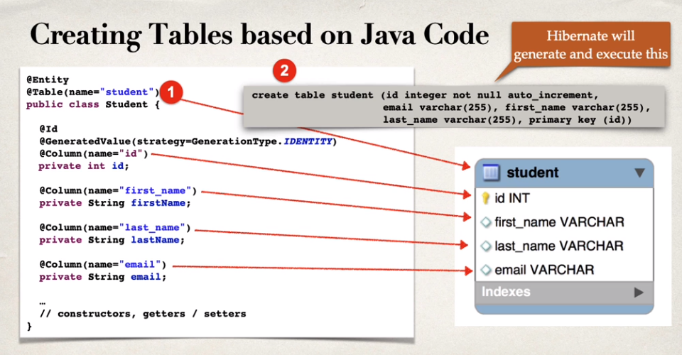 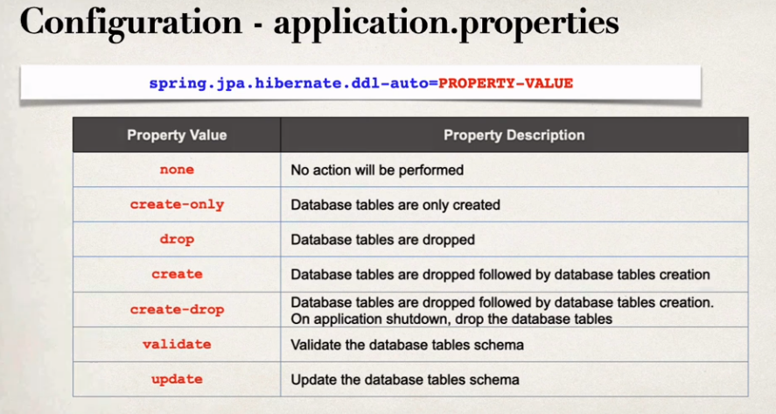

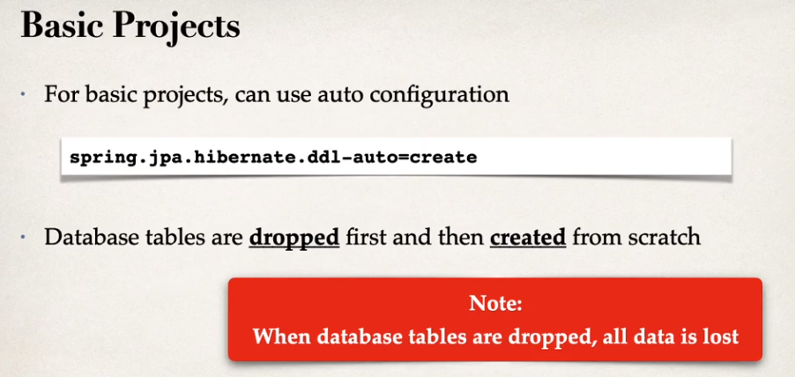 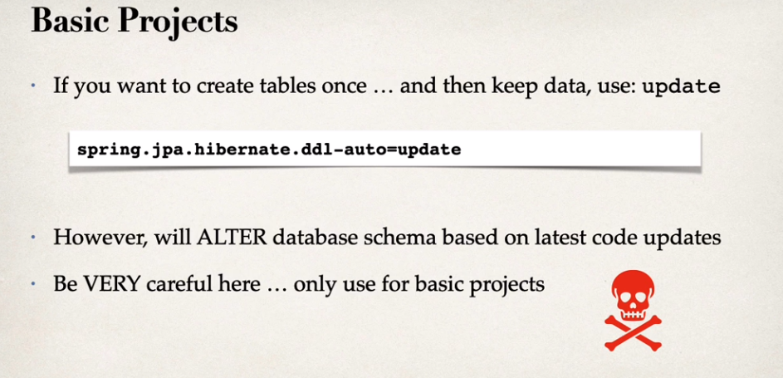

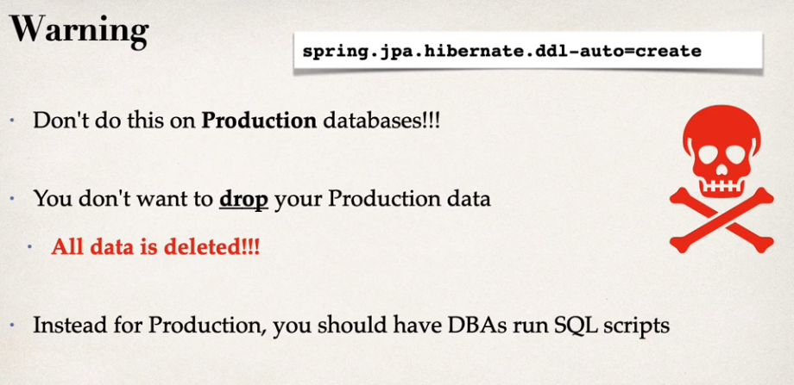 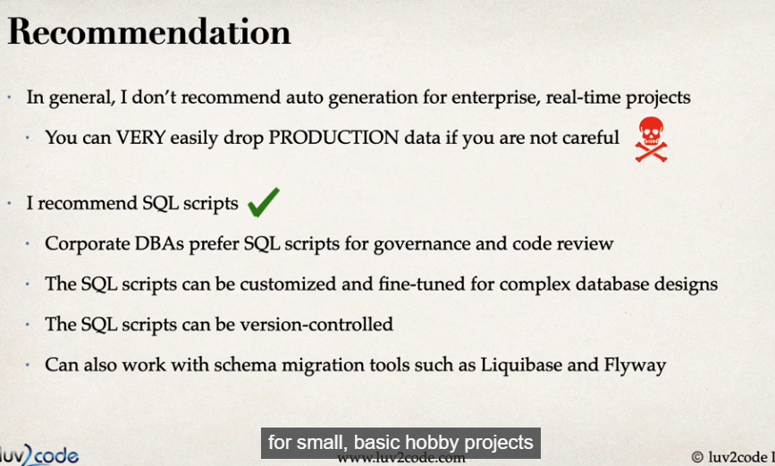

**REST CRUD APIs**

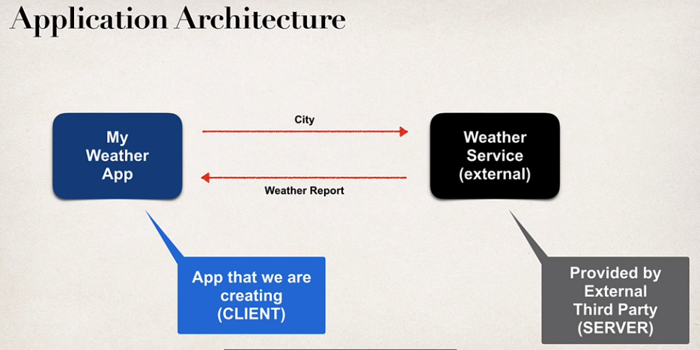

**JSON**

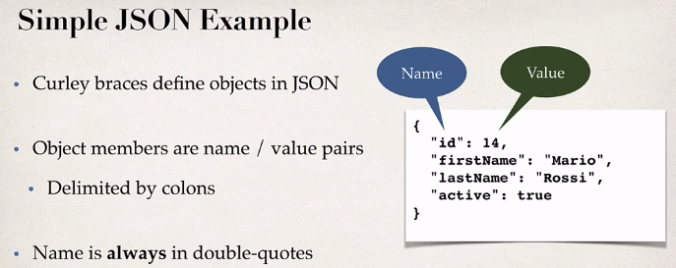

**Spring Boot Rest HTTP**

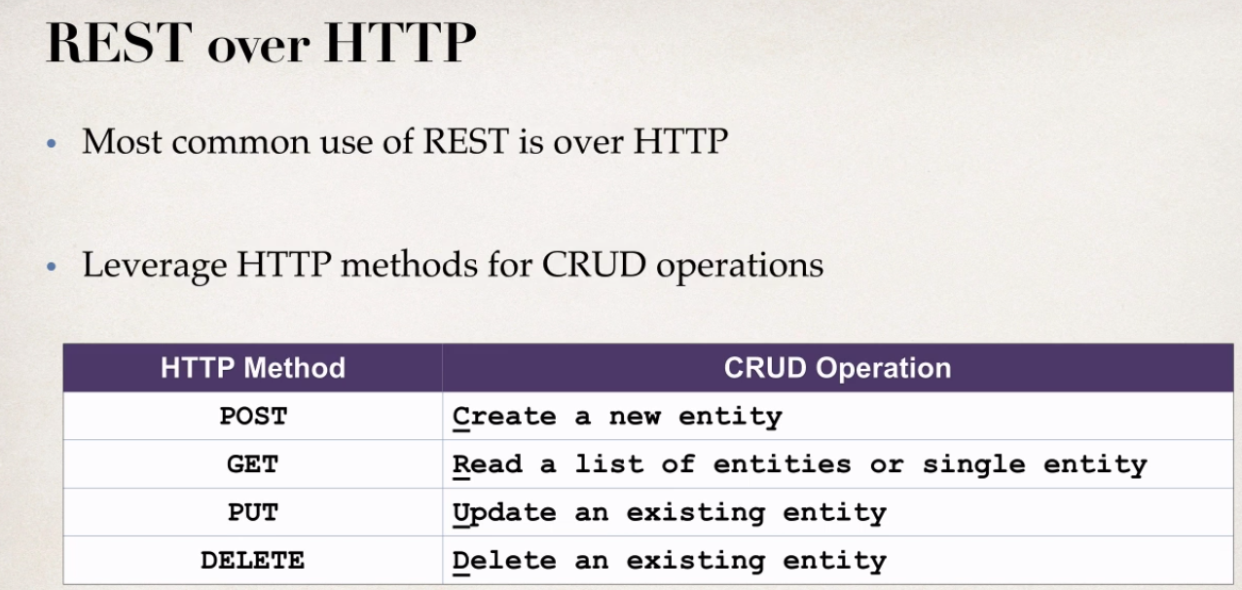

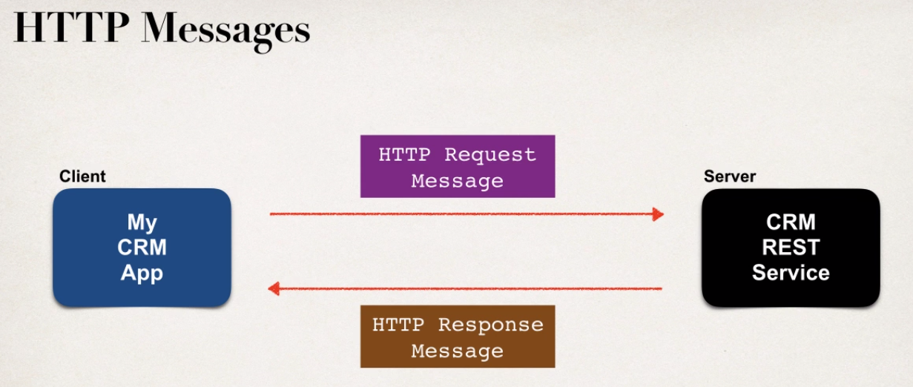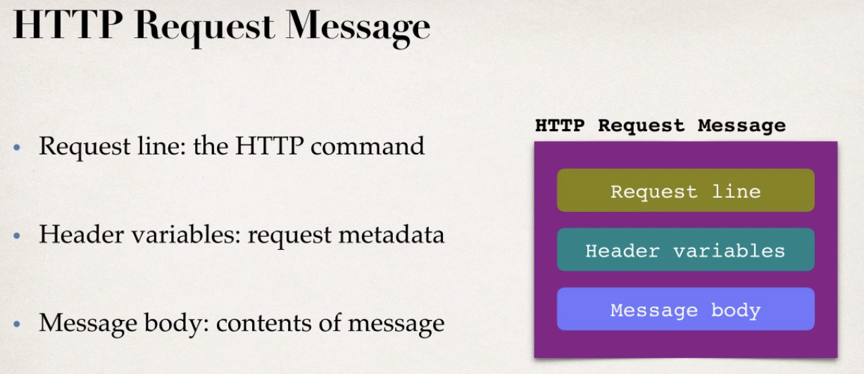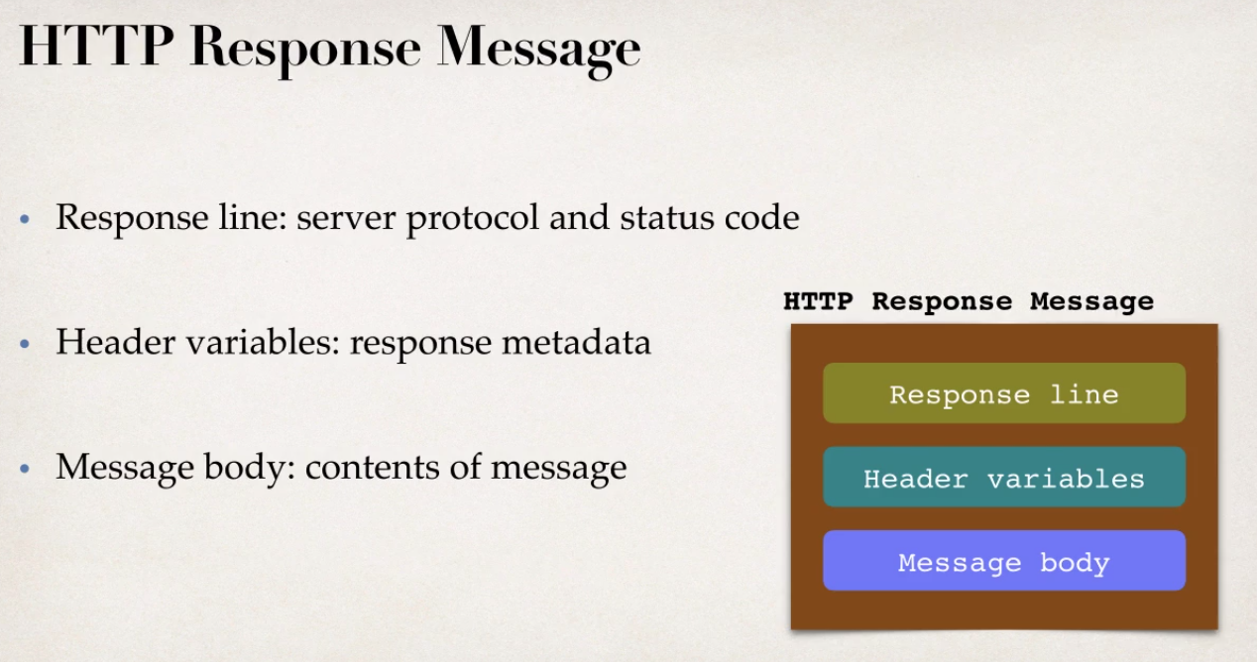

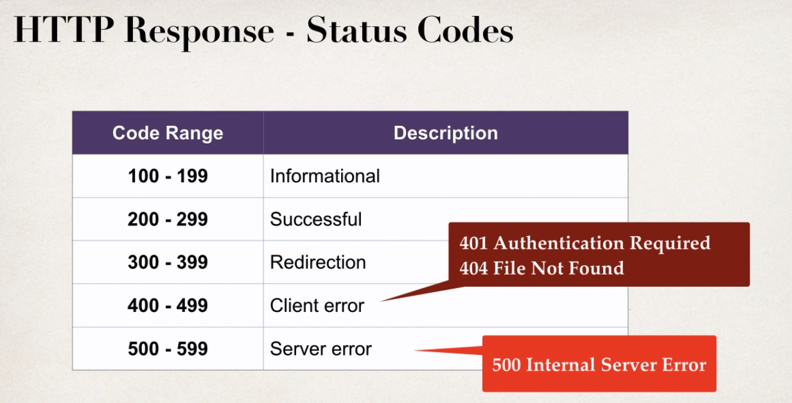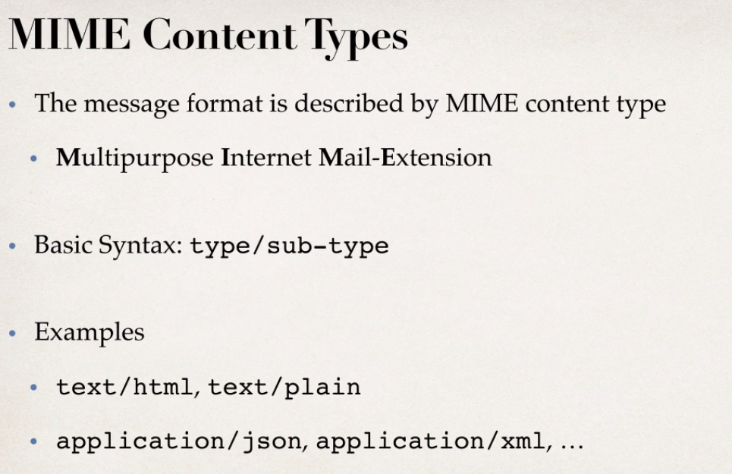

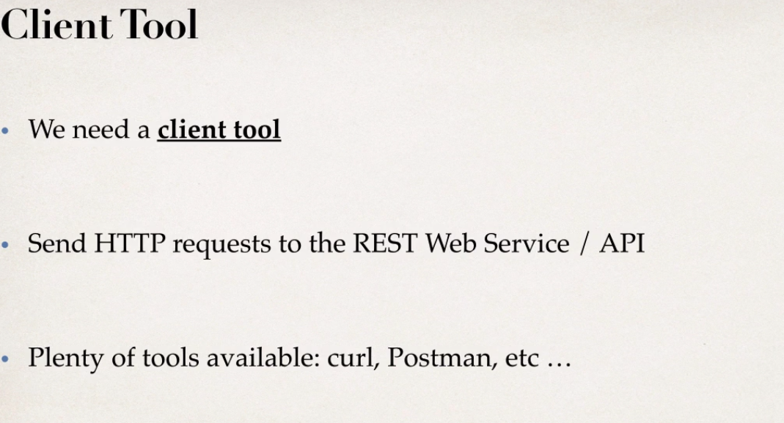

**Java JSON Data Binding**

* + Data Binding is Process of converting JSON data to a Java POJO

So it’ll read the contents of that JSON string or file and then populate the Java object with that given data. Or you can go the other way. We can start with the Java POJO and then send it down to an actual JSON string or JSON file. Now this whole process is called ***data binding***. It’s also known as **Mapping** ,**Serialization / Deserialization**, **Marshalling / Unmarshalling**

Data Binding in Spring used **Jackson Project!**

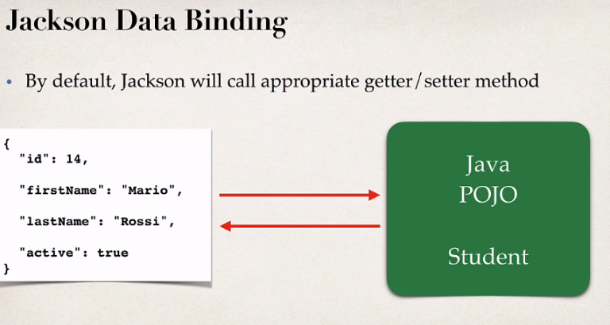**JSON to POJO** OR **POJO (student) to JSON**

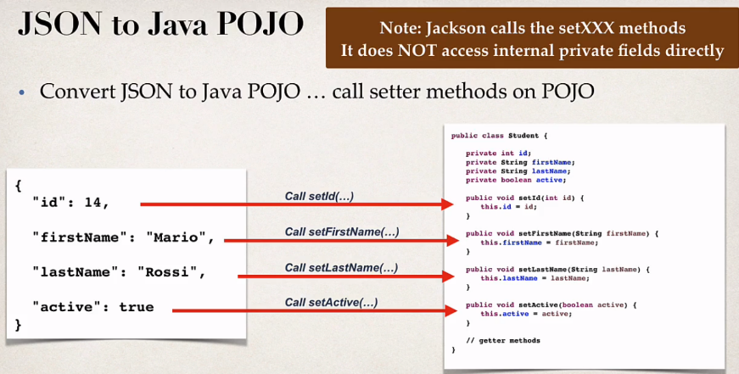**JSON to POJO**

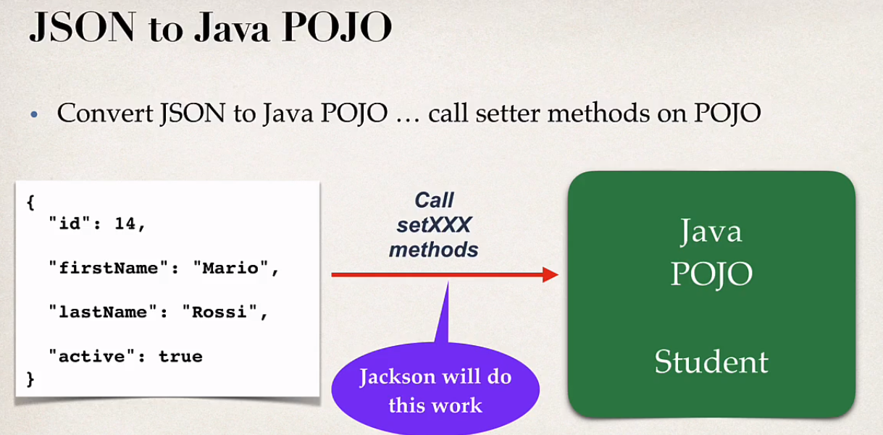

**POJO to JSON**

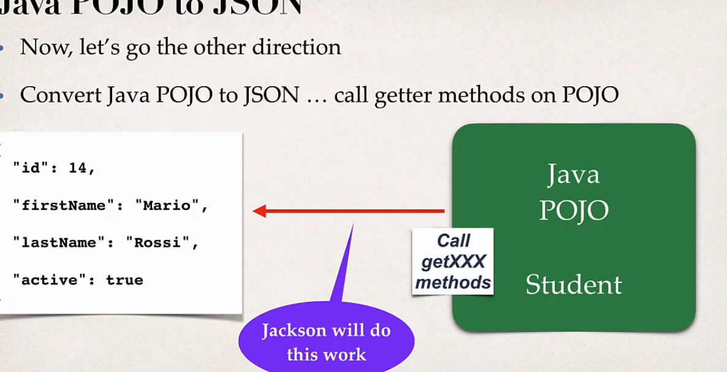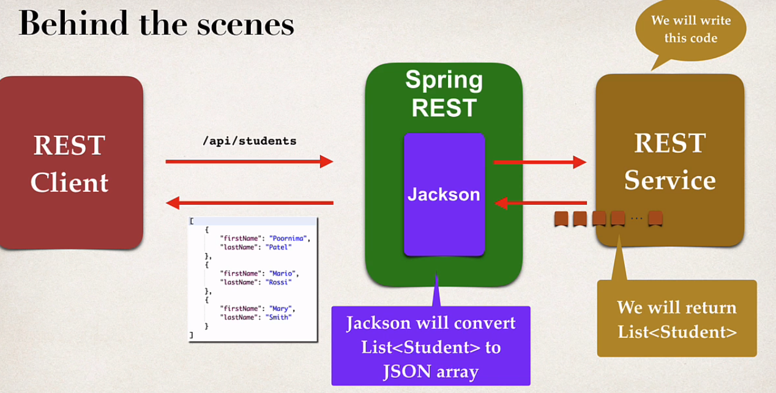

**Path Variable**

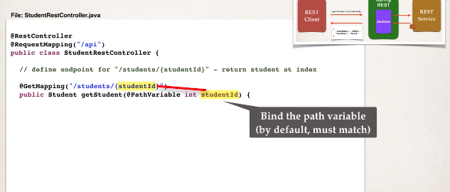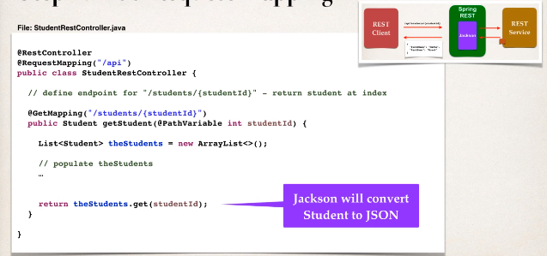

**Using @PostConstruct**

The *PostConstruct* annotation is used on a method that needs to be executed after dependency injection is done to perform any initialization. This method MUST be invoked before the class is put into service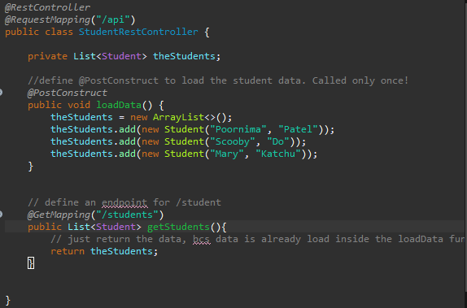.

**Exception Handler**

Using exception handler to handling the error with *@ExceptionHandler* annotation. The handler will return a *ResponseEntity* , a wrapper for the HTTP response object.

